INSPECTION & SPECIFICATION SERVICES CC.
ISS
CONTROLLED ENGINEERING INSPECTION REPORT
Combined-Product Spillage
Inspection and Engineering Assessment Report
South32 Wessels Mine · Surface and Underground Conveyor / Process Areas
TERMINOLOGY-REFINED DRAFT · REVISION 0.5 · NOT FOR ISSUE

Client | South32
Mine / site | Wessels Mine
Area / system | Combined-product handling and processing systems - selected surface and underground sections
Report number | S32WPPSR-01
Revision | 0.5 - Terminology-Refined Draft
Issue date | 25 August 2026
Inspection date / range | [INSPECTION DATE / DATE RANGE]
Prepared by | Inspection & Specification Services cc.
Inspection & Specification Services cc.
Reg. No. 1990/020258/23
24 Jonkershoek Street, Vaalpark, 1947
iss@inspecserv.co.za

Document Control and Metadata
Table 1 - Document control and report metadata
Field | Value
Report title | Combined-Product Spillage Inspection and Engineering Assessment Report
Report number | S32WPPSR-01
Revision | 0.5
Issue status | Terminology-Refined Draft / Not for Issue
Issue date | 25 August 2026
Client | South32
Mine / site | Wessels Mine
System | Combined-product handling and processing systems
Primary drafting source | Running_Report_Contextual_Spillage_NotesV3.9.docx + Phase 6/7 Addenda + V3.12 Language Style Addendum + V3.13 Terminology Refinement Addendum
Evidence register | EVIDENCE_STORY_MATRIX_V0.1.csv — 197 controlled media / 75 E / 44 S / 78 A / 0 X
Template lineage | Adapted from ISS Sheave Inspection Report Master Template v2.1 structure

Prepared, Reviewed and Approved
Table 2 - Document authorization record
Role | Name | Title / Discipline | Date | Signature
Prepared by | [PREPARED BY] | [TITLE] | [DATE]
Reviewed by | [REVIEWED BY] | [TITLE] | [DATE]
Approved by | [APPROVED BY] | [TITLE] | [DATE]

Revision History
Table 3 - Revision history
Revision | Date | Change description | Prepared by | Approved by
0.1 | [DATE] | Initial spillage-report working base adapted from ISS sheave-report structure using consolidated Contextual Notes V3.7 and completed evidence review. | [NAME] | [NAME]
0.2 | 25 Aug 2026 | Phase 6 assembly draft: accepted narrative architecture + evidence hierarchy + CV09 holistic evidence grammar integrated into one full report structure. | ISS | Draft review
0.3 | 25 Aug 2026 | Phase 7 compilation draft: refined Parts I-XII, mature action programme, verification register, technical appendices and current conceptual engineering figures compiled into the approved V0.2 report architecture. | ISS | Draft review
0.4 | 25 Aug 2026 | Language-harmonised revision: V0.3 engineering substance retained while reader-facing narrative was aligned to the accepted V0.2 softer formal-engineering style under Context V3.12. | ISS | Draft review
0.5 | 25 Aug 2026 | Global terminology refinement: reader-facing uses of “envelope” were replaced with direct physical terms such as material-handling path, carrying path, process stream/process path and installation space. “Envelope” is retained only where it describes a defined geometric or operating range, such as belt tracking or normal operating envelope. | ISS | Draft review

Controlled Distribution
Table 4 - Controlled distribution list
Recipient / role | Organisation | Purpose | Controlled copy
[CLIENT CONTACT] | South32 | Review / action tracking | [YES / NO]
[ISS FILE] | ISS | Controlled project record | Yes
TERMINOLOGY-REFINEMENT CONTROL NOTE
This revision builds on the V0.4 language-harmonised draft and applies the first controlled report-wide terminology refinement. Reader-facing uses of “envelope” have been replaced with direct physical language where the report is describing the material path, carrying path, process stream, chute/process route, screening/washing process or available installation space. The term “envelope” is retained only where it has a specific engineering purpose in describing a defined geometric or operating range, such as belt tracking or normal belt operating movement.
This file remains NOT FOR ISSUE. The terminology refinement does not alter the established evidence qualifications, engineering conclusions, recommendations or verification requirements. The V0.2 explanatory narrative style remains the governing reader-facing language standard under Context V3.12.

Table of Contents
1 Executive Summary
2 Purpose and Objectives
3 Scope of the Audit
4 Methodology, Evidence Basis and Limitations
5 The Material Journey
6 Central Audit Principle — Spillage Location Is Not Always Cause Location
7 The Overall Spillage Picture
8 Fines Are Being Lost Progressively Through the Conveyor Ecosystem
9 Why Belt Cleaning Alone Is Not the Full Control Function
10 Cleaner / Fines-Control Philosophy and CV09 Pilot
11 The Containment Problem Is Not Limited to Fines
12 W10 — Coarse Product Loss in a Confined Tunnel
13 Sample Conveyors — Product Size, Feed and Limited Carrying Width
14 Belt Tracking as a Material-Containment Requirement
15 U4 Tripper Car — Strong Local Cause-and-Effect Example
16 L3 — Alignment Concern Without Proven Solid-Product Causal Chain
17 Water as a Material-Transport and Deterioration Mechanism
18 Screens — Confirmed Water Escape / Separate Structural Story
19 L1 — Spillage, Historical Belt Contact and Structural Deterioration
20 Trips, Restart and Manual Product Removal
21 Housekeeping — Necessary but Not the Primary Solution
22 Consolidated Engineering Interpretation
23 Engineering Control Philosophy — Keep the Combined Product Inside the Process
24 Programme Structure and Implementation Principle
25 Priority 2 — Correct or Verify Local Material-Loss / Alignment Mechanisms
26 Priority 3 — Water Containment and Structural Actions
27 Priority 4 — Extend Proven Controls Where Applicable
28 Priority 5 — Operational and Housekeeping Governance
29 Conclusion
Page numbers remain provisional in this V0.5 terminology-refined draft. The automatic Table of Contents, List of Figures, List of Tables and final cross-references will be refreshed during the later publication-formatting pass.

List of Figures
Figure numbering and final captions remain provisional at this stage. Canonical evidence IDs and controlled conceptual-drawing IDs are retained so the final List of Figures can be generated without losing traceability.

List of Tables
Table numbering and final cross-references will be refreshed during the publication-formatting pass after the V0.5 content review.

PART I — WHY THE AUDIT WAS UNDERTAKEN

1 Executive Summary
Spillage was observed at multiple locations across the Wessels material-handling system, from the underground crusher and conveyor route through the surface screening and loading-station areas. The audit was undertaken to determine whether these deposits were isolated housekeeping problems or evidence of broader failures to keep product and process water within their intended material-handling and process paths.
The audit found that there is no single universal spillage mechanism. The strongest recurring system pattern is fines/carryback, supported by repeated fines accumulation along return-side and downstream conveyor areas. Additional local mechanisms include coarse or mixed product leaving the intended carrying path during transit, belt mistracking/alignment, limited loading or side-containment margin, process-water escape, and event-driven material removal following trips or restart preparation.
A central finding is that the location where spilled material accumulates is not necessarily the location where the initiating failure occurs. Fines may remain on a return belt after discharge and detach progressively downstream; water may mobilise fines away from an original escape point; mistracking may develop before product is lost; and trip/restart clearing can create a secondary deposit away from the initiating event.
Taken together, the evidence indicates that increased housekeeping alone will not provide a sustainable long-term solution. Housekeeping remains necessary for safe access and product recovery, but recurring deposits indicate that the underlying material-loss mechanism also needs to be addressed.
AUDIT TAKEAWAY | The mine has a material-containment problem with several mechanisms, not simply a housekeeping problem or a collection of unrelated scraper defects.
The higher-order engineering objective is therefore to keep the combined product — fines and coarse/lump ore — within the intended material-handling path throughout transit and to keep process water within the screening and processing systems where it is intended to remain, using controls appropriate to the particular failure mechanism and local geometry.
The recommended programme therefore combines a system-level source-control philosophy with targeted local actions. CV09 is the preferred pilot for development of an integrated cleaner-and-containment function. U4, Sample Conveyors 2 and 3, W10, the Screens, L1 and L3 require location-specific inspection, measurement or corrective work because their mechanisms, evidence and geometry differ. The effectiveness of these actions should ultimately be checked under representative operating conditions rather than judged only by completion of the work or a temporarily clean area.

2 Purpose and Objectives
The purpose of the audit is to identify where combined product or process water is escaping its intended handling path, determine the mechanisms and contributing conditions associated with those losses where the available evidence allows, distinguish recurring system mechanisms from local asset-specific conditions, and define practical engineering, maintenance and operational actions that can reduce recurrence.
- Identify the material types and locations at which visible losses occur.
- Determine the immediate mechanism and contributing condition where the available evidence supports that conclusion.
- Distinguish visually proven conditions from inspector-recorded observations, engineering interpretation and unresolved verification items.
- Develop practical source-control, containment, maintenance, alignment, structural and operational actions.
- Provide a controlled evidence record that allows engineering and maintenance personnel to trace each major conclusion back to the inspection evidence.
The audit is qualitative and mechanism-focused. It does not attempt to infer total lost tonnage or volume from photographs, and unverified numerical tolerances, feed rates, structural capacities or OEM limits are not introduced as report facts. Visible extent is used to describe the inspected condition, while values that were not measured remain items for later measurement, design development or competent assessment.

3 Scope of the Audit
The inspected locations form one connected material-handling route and are treated as an ecosystem rather than as an unrelated list of assets.
Process area | Included assets / groups
Underground — Central Block | Underground Crusher; UC05 / UC04 / UC03 / UC02 / UC01 continuous conveyor system
Underground — Secondary Plant | U3 Conveyor; U4 Tripper Car
Underground — Silos / Feeders | U5A Conveyor; U5B Conveyor
Surface — Screening / Transfer | W10; CV01; CV02; CV03; CV04; CV06; CV09; CV14; CV15; Screens / screen chutes
Surface — Loading Station | L1; L2; L3; L4; Sample Conveyors 1, 2 and 3
CV05, CV07, CV08, CV10, CV11, CV12 and CV13 are outside the integrated scope of this report. The evidence record remains limited to the 23 controlled inspection groups represented in the final evidence matrix.

4 Methodology, Evidence Basis and Limitations
The assessment combines site inspection observations, still photographs, inspection videos, the completed questionnaires, the consolidated contextual engineering notes, the controlled visual-review records and the final 197-item evidence/story matrix. Each evidence item retains its canonical ID so that the report body can remain readable without losing the technical traceability required by engineering and maintenance readers.
Evidence / statement type | Meaning in this report
Direct observation | Condition recorded directly during the inspection by the inspector.
Visual evidence-supported | Condition materially demonstrated by supplied photographs or video.
Source-recorded information | Operating, maintenance or historical information retained from inspection records/questionnaires.
Engineering interpretation / hypothesis | Reasoned explanation consistent with the observed condition but not fully proven by the available evidence.
Working remedial concept | Engineering direction requiring measurement, feasibility and design verification before implementation.
Unresolved / requires verification | Condition or magnitude that cannot be responsibly closed from the present evidence.
The inspection was performed around operating industrial equipment and access was therefore limited at some points. Where belt geometry, offset magnitude, cleaner contact or wear travel, feed quantity, remaining structural capacity, chute dimensions or design limits were not measured, the report deliberately carries those items forward for verification, design development or competent assessment rather than inferring a value. This is particularly relevant to the Sample Conveyor tracking conditions, U4 and L3 alignment, the precise Screens water-escape mechanism, and the L1 belt-contact and structural conditions, all of which retain the qualifications described in their respective sections.
PART II — UNDERSTANDING THE MATERIAL-HANDLING SYSTEM

5 The Material Journey
The material handled by the inspected system is combined product comprising lump/coarse ore together with fines. Fines are already present in the product stream and additional fines are generated through crushing and subsequent handling. Their presence is therefore not itself a defect; the audit concern begins when product or process water leaves its intended material-handling or process path before reaching the stage designed to receive or control it.
From the underground crusher onward, the conveyor system is intended to transport the combined product through successive transfer and processing stages while retaining it inside the designed material path. Residual carryback should be removed at appropriate discharge locations and kept within the process, process water should remain within the screening/washing process, and material deliberately removed during unavoidable operating interventions should be controlled and recovered in a defined manner.
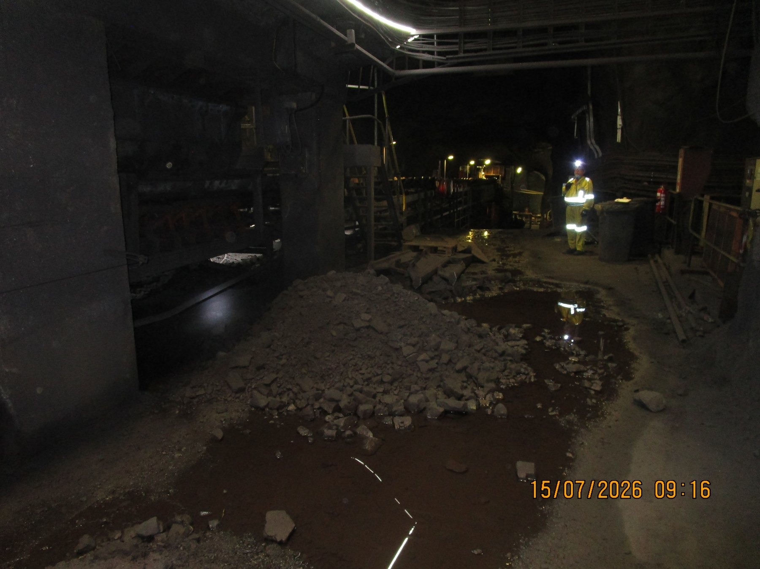  UGCrusher-REF-001 — mixed lump/fines accumulation at the underground start of the inspected conveyor ecosystem. | 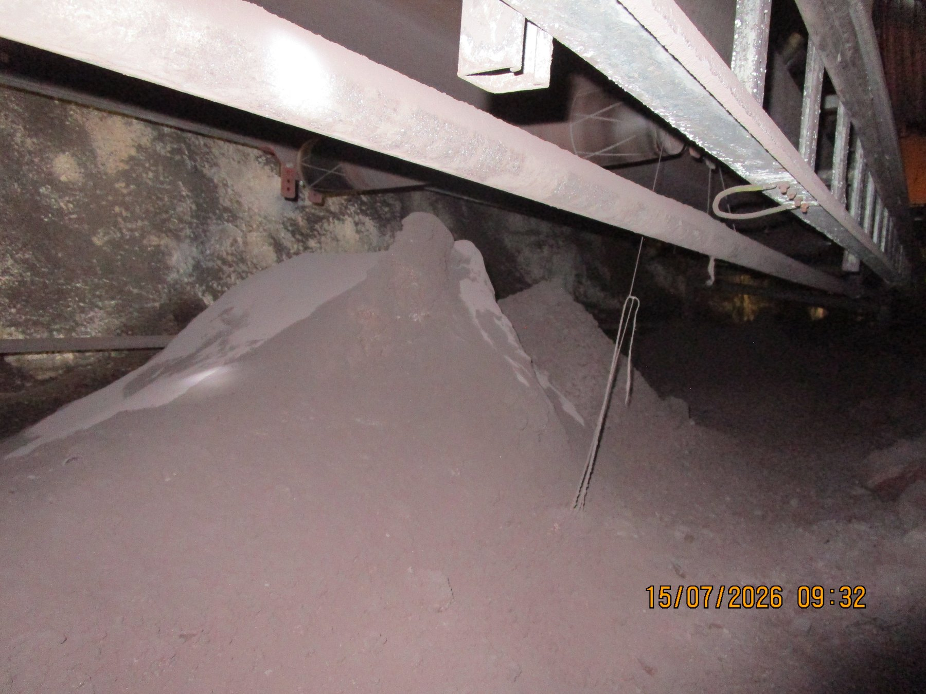  UGUC05_04_03_02_01-REF-006 — severe local accumulation along the continuous underground conveyor route.
READER TAKEAWAY | The report concerns loss of process containment during transport — not the mere presence of fines, lump ore or process water within the material-handling system.

6 Central Audit Principle — Spillage Location Is Not Always Cause Location
Visible spillage should not automatically be interpreted as a local equipment failure at the point where the material is found. A deposit may be the final consequence of an initiating condition that is upstream or functionally separate from the deposit location. For this reason, the assessment considers the observed deposit, the material type, the immediate mechanism, possible contributing conditions and the most appropriate control in sequence. Where the initiating cause cannot be established from the available evidence, the report leaves that point open for further verification rather than assigning an unsupported cause.
1. Fines/carryback can remain on the return belt after intended discharge and detach progressively as the belt flexes over downstream rollers.
2. Process or cleaning water can mobilise fines and transport contamination away from the original escape point.
3. Belt mistracking can reduce usable carrying margin before coarse/mixed product is lost at a later location.
4. Trip/restart clearing can place product beside a conveyor even when the initiating trip, blockage or intervention occurred elsewhere.
CAUSE / EFFECT SEQUENCE | Observed deposit → material type → immediate mechanism → contributing condition → initiating cause → consequence → control
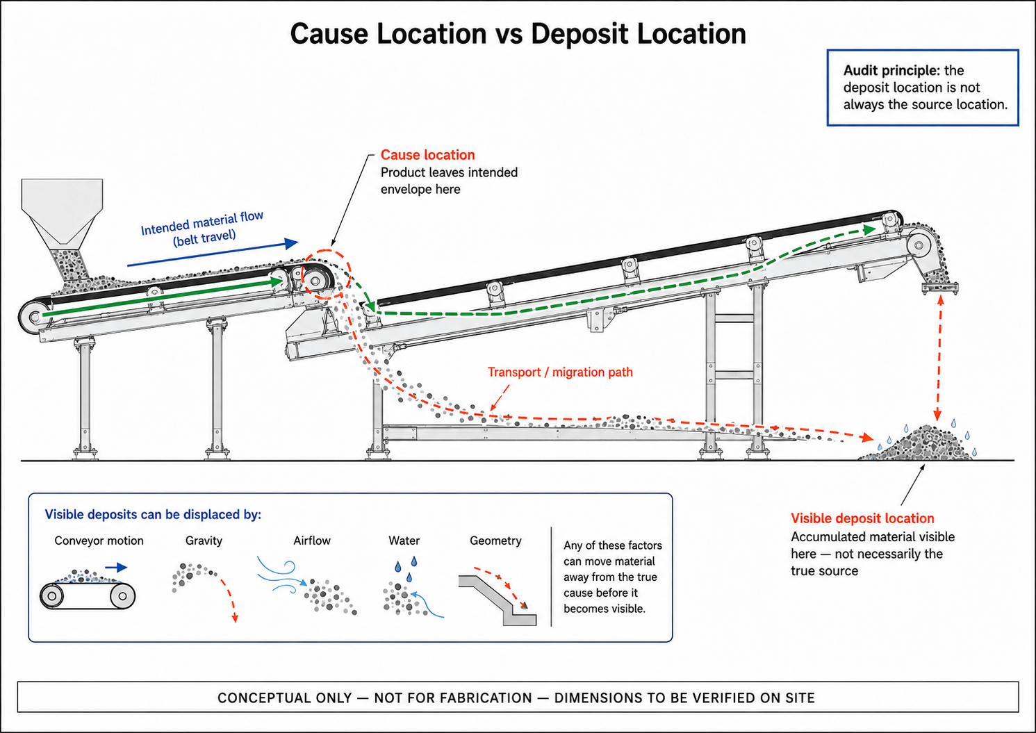
CTD-004 — Cause Location vs Deposit Location. Conceptual explanatory figure; not inspection evidence.
PART III — WHAT THE AUDIT FOUND

7 The Overall Spillage Picture
The evidence resolves into three recurring material-loss families and one event-driven operating mechanism: fines/carryback; coarse or mixed-product loss during transit; water-related escape, wet fines and slurry; and material removed during trip/restart or other operating interventions. These mechanisms can overlap at individual assets, but they do not all require the same physical control.
Mechanism family | Typical evidence / significance |  | Control direction
Fines / carryback | Recurring deposits along return-side and downstream conveyor areas; cleaner condition and containment are recurring themes. |  | Improve cleaning function and retain removed fines inside the process.
Coarse / mixed product transit loss | Product outside the intended carrying path at W10, Sample Conveyors and other local positions. |  | Feed/trajectory, tracking and location-specific containment.
Water / wet fines / slurry | Wet deposits and confirmed active screen water escape. |  | Retain process water; identify local escape mechanism; manage secondary structural consequences.
Trip / restart unloading | Source-recorded manual clearing after trips/blockages. |  | Defined temporary laydown, recovery and restart procedure.
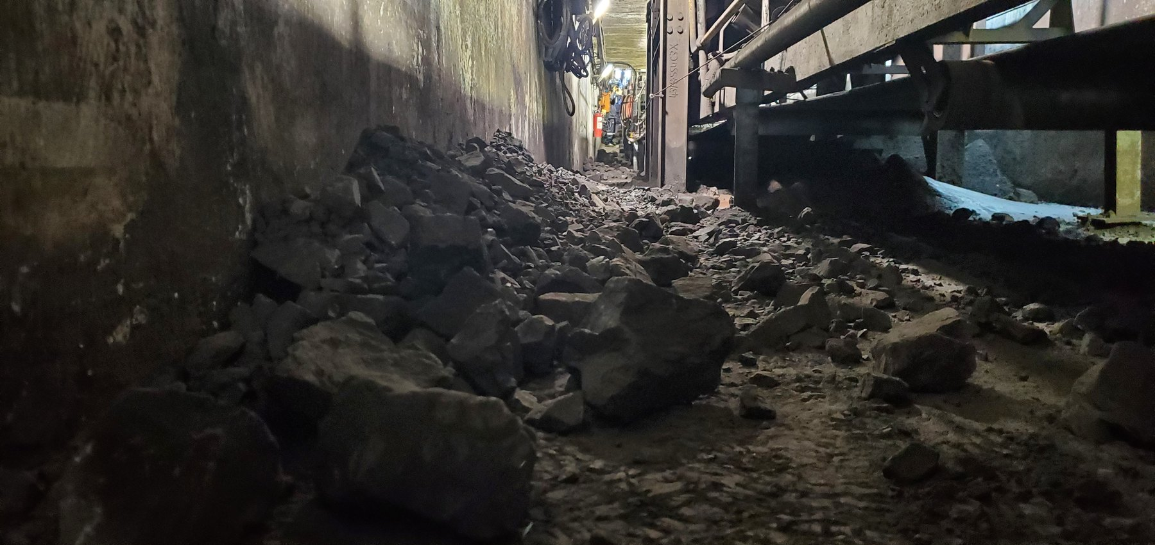  W10-REF-002 — coarse/mixed product occupying restricted tunnel access. |  | 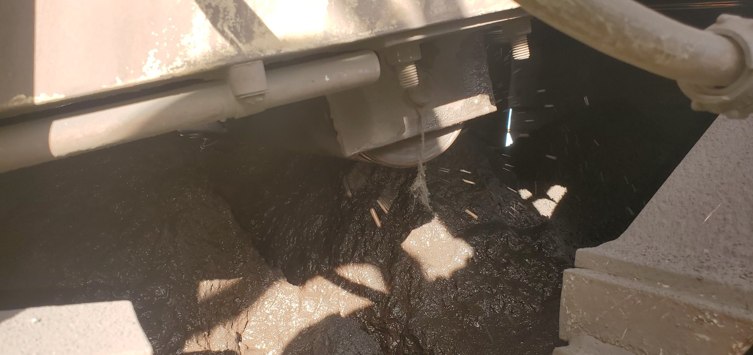  CV04-REF-002 — saturated wet-fines/slurry condition.
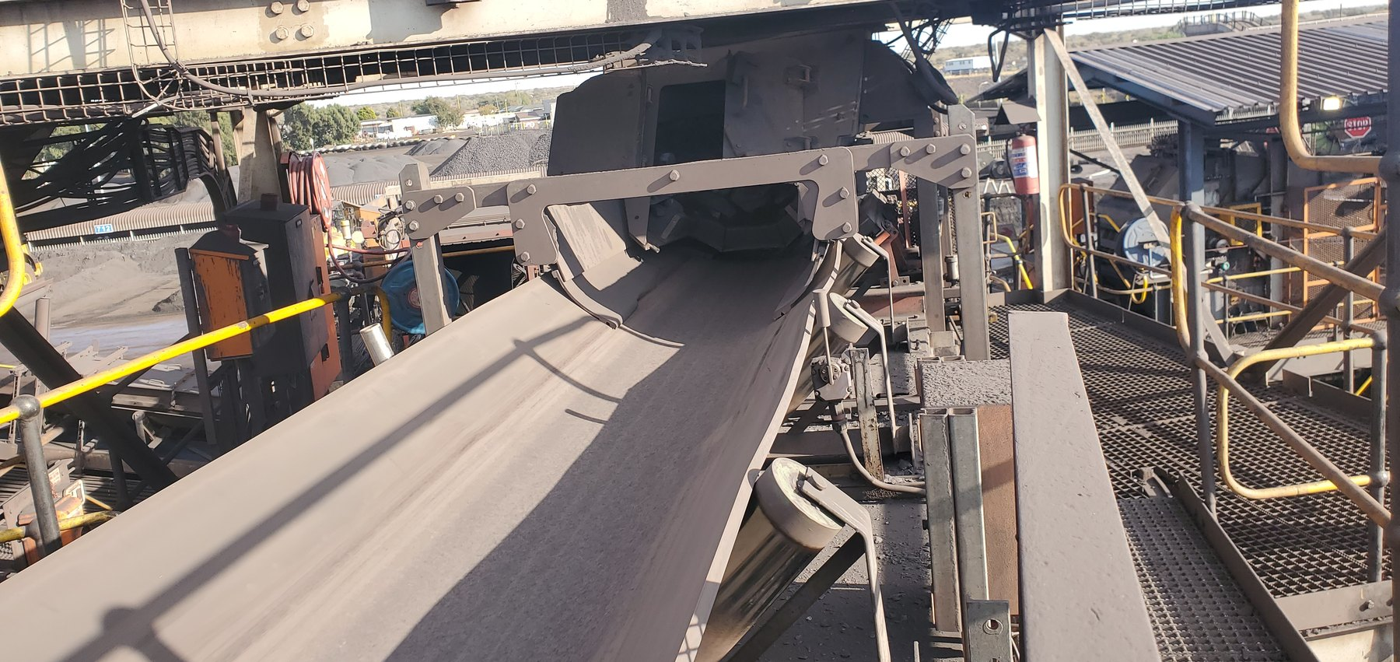  CV03-REF-002 — clean-condition comparator demonstrating that not every inspected conveyor was a significant spillage location. |  | 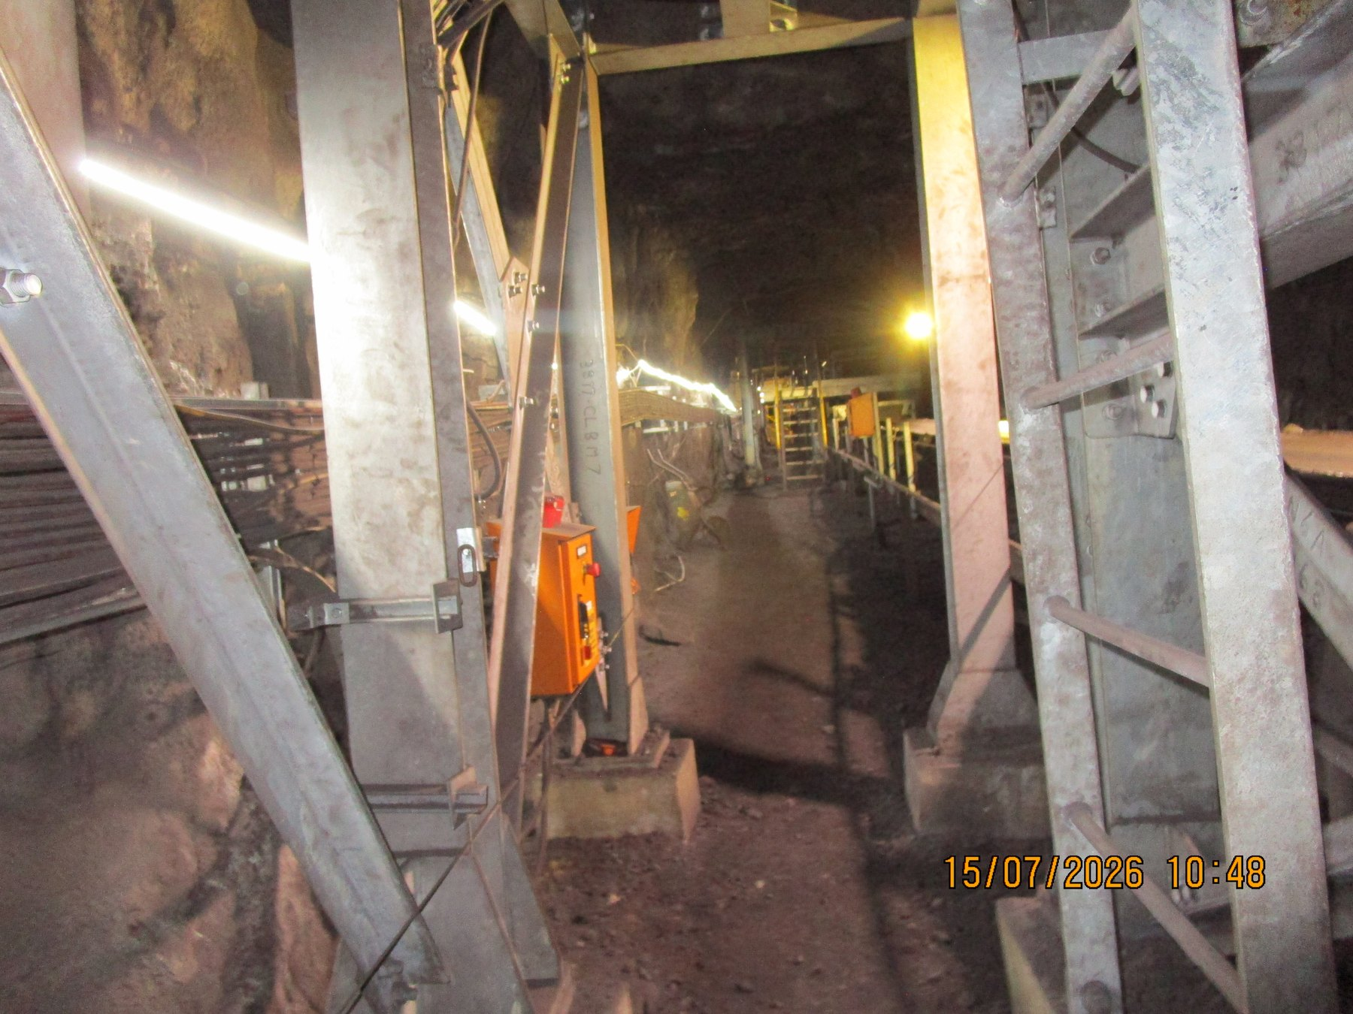  UG5B-REF-006 — wider comparator supporting a localised rather than uniformly widespread U5B condition.
PART IV — FINES, CARRYBACK AND CLEANER CONTAINMENT

8 Fines Are Being Lost Progressively Through the Conveyor Ecosystem
Recurring fines accumulation was observed across multiple underground and surface conveyor areas. The repeated relationship between deposits and return-belt/support-roller areas is consistent with carryback being a major recurring mechanism, particularly downstream of discharge locations. The photographs clearly demonstrate the resulting accumulation, although they do not establish that every individual deposit has the same sole origin.
The cross-system recurrence is important because the visible deposit may occur some distance downstream of the cleaner or discharge point at which the material should originally have been controlled. Residual material can detach progressively as the return belt flexes and passes over rollers, with vibration and gravity contributing to the final deposit location. Wet or sticky conditions can increase the tendency for fines to remain adhered, although the report does not assume one common water source for all locations.
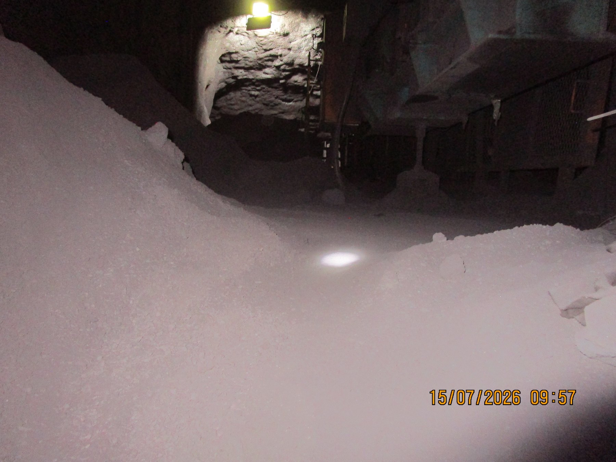  UGUC05_04_03_02_01-REF-015 — wider longitudinal accumulation supporting recurrence along the underground route. | 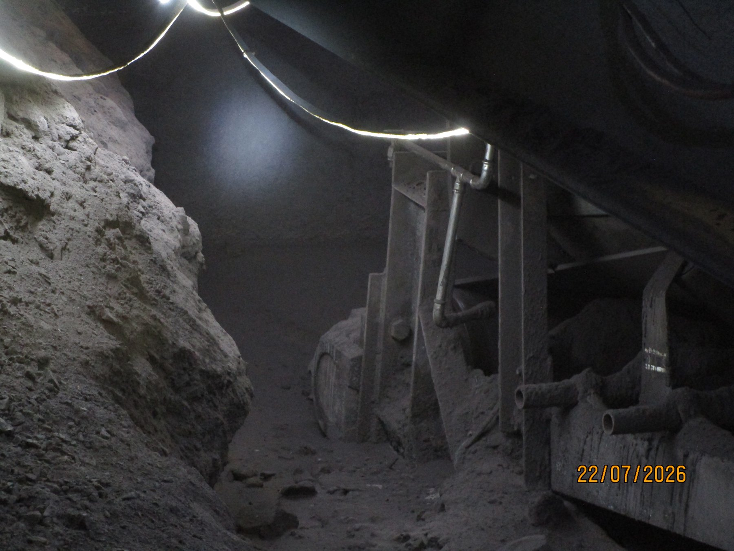  UG5A-REF-006 — widespread return-side accumulation at U5A.
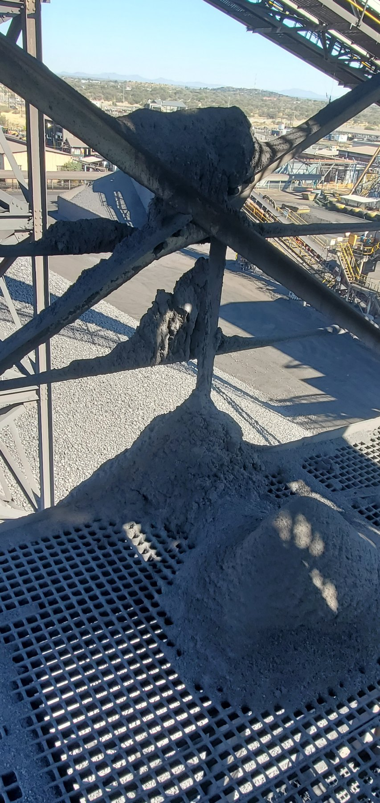  CV15-REF-004 — large fines deposits on grating/cross-bracing around the CV15 discharge region. | 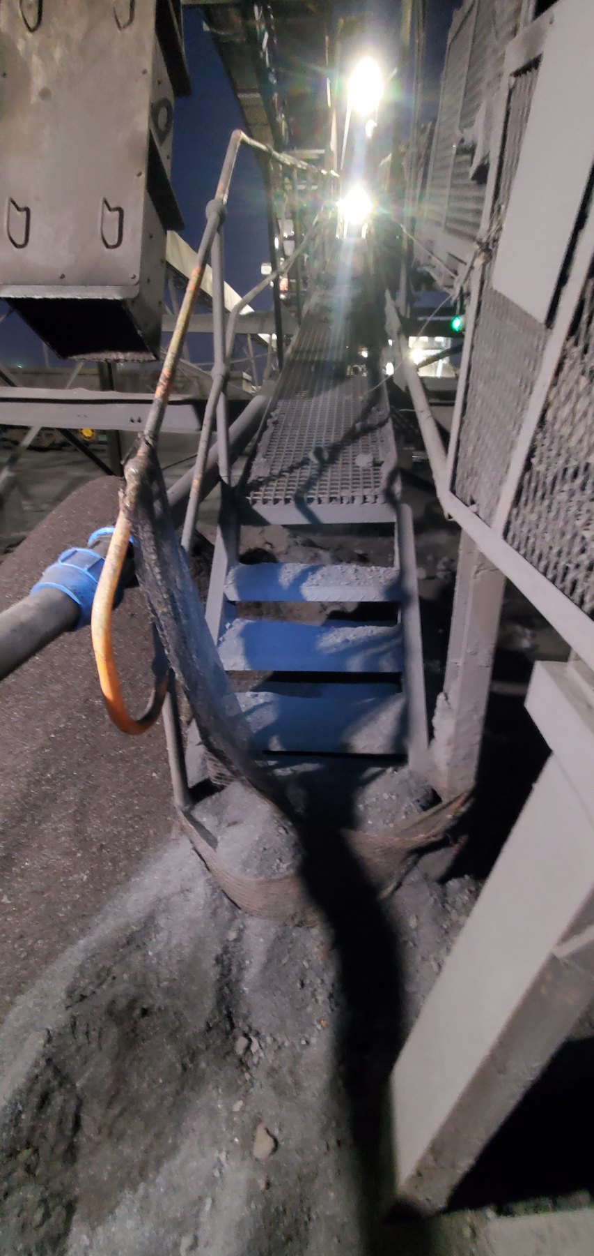  LoadoutStationSample1-REF-002 — substantial fines accumulation around the Sample Conveyor 1 tail/access area.
SYSTEM PATTERN | Carryback is a recurring system mechanism, not an isolated conveyor event. The report therefore focuses on cleaner function and containment at relevant discharges while retaining the evidence qualification applicable to each individual deposit.

9 Why Belt Cleaning Alone Is Not the Full Control Function
A belt cleaner succeeds only when two linked functions are achieved: residual material is removed from the return belt, and the removed material remains inside the intended process/material path. CV06 and CV09 demonstrate different ways in which that overall control function can fail.

9.1 CV06 — Mechanical / Maintenance Failure Example
At CV06 the cleaner cannot perform its intended function because the physical cleaner condition is compromised. The support structure remains installed, but scraper blade elements are absent across the working belt width and a support bush/insert is displaced. The photographs do not establish why the bush displaced or why and when the blades were lost; those remain maintenance or design-history questions. The first step is therefore to restore the cleaner and confirm the condition of the complete arrangement before considering broader redesign.
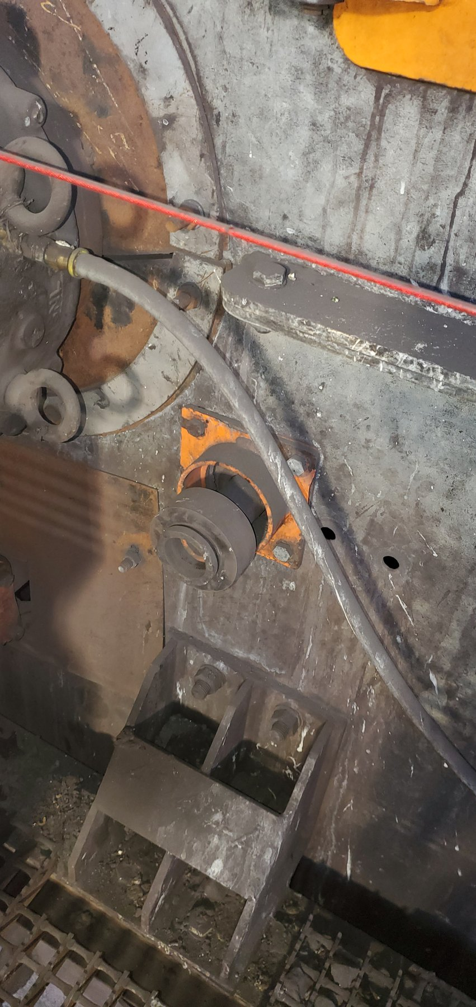  CV06-REF-004 — displaced cleaner support bush/insert. |  | 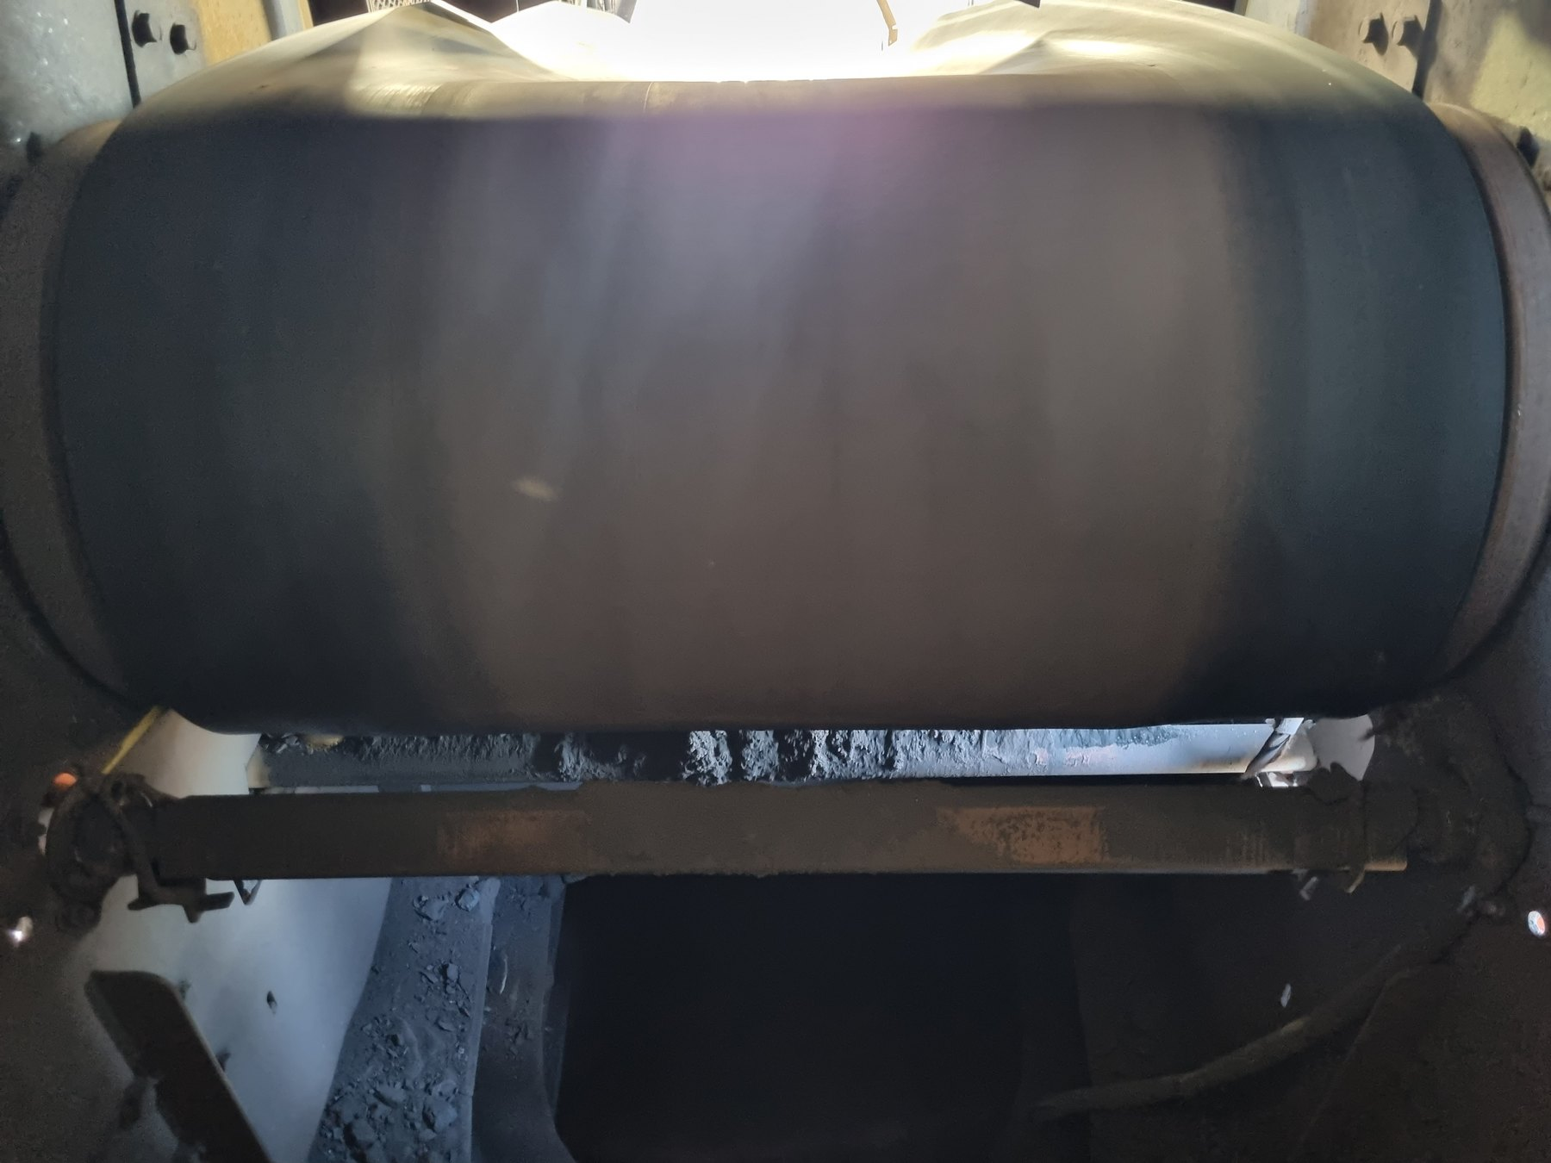  CV06-REF-005 — cleaner support structure present with scraper blades absent from the working belt width.
OBSERVATION | Physical cleaner defects are directly visible at CV06.
ENGINEERING ASSESSMENT | The cleaner is non-functional as intended. The photographs do not establish why the bush displaced or why/when the blades were lost; those remain maintenance/design-history questions.
RECOMMENDED NEXT ACTION | Restore a functional cleaner arrangement and verify the support/housing condition, blade installation, belt contact and maintainability before returning the cleaner to service.

9.2 CV09 — Cleaner Removes Material, But Containment Still Fails
CV09 demonstrates a different problem. Wet residual material is removed in the cleaner/discharge region, but the local arrangement does not adequately retain that material within the intended process/fines-discharge path. Active wet-material fallout was recorded during operation. The evidence therefore makes CV09 a useful cleaner-and-containment pilot location, while final cleaner type, cleaning stages, contact pressure, travel, support and chute geometry still require site measurement and design development.
This matters because belt cleaning and containment of the removed material are one engineering function. At CV09 the cleaner and the local containment arrangement should therefore be considered together. The pilot should first record the as-found condition and verify the available geometry and access, then provide a controlled route for removed fines back into the intended process stream and confirm the result under representative wet/sticky service.
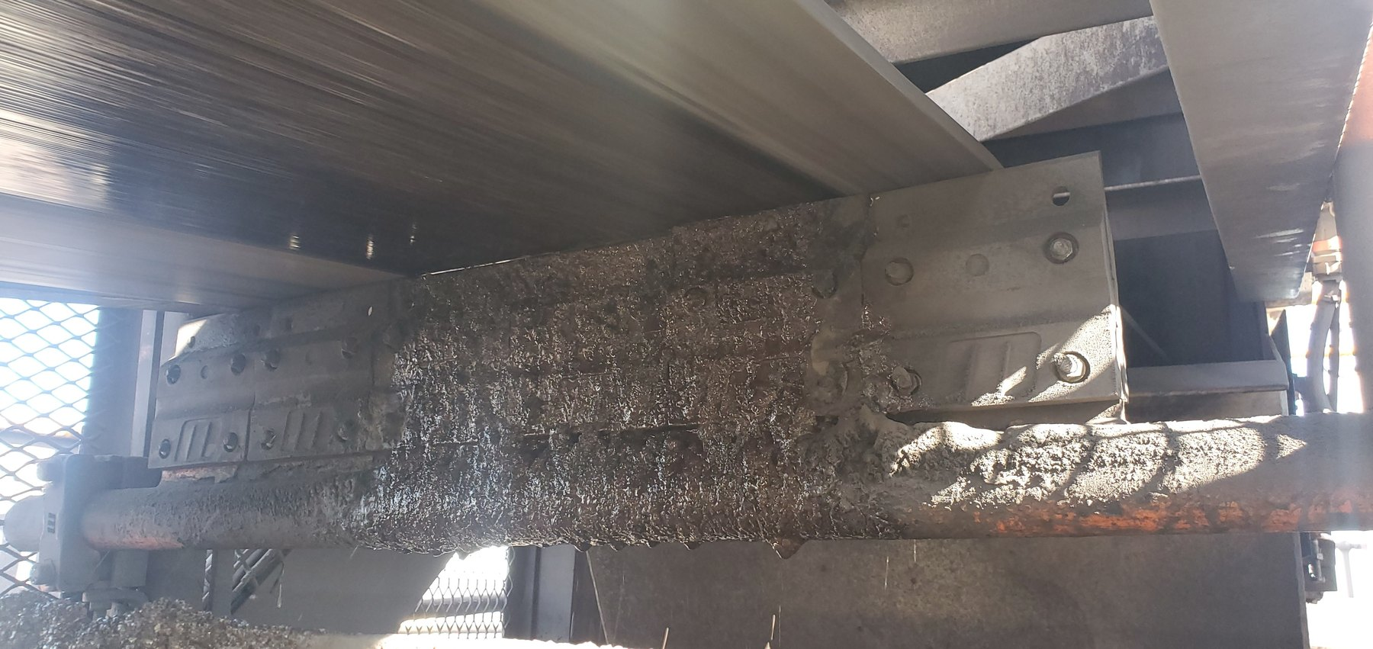  CV09-REF-003 — principal still showing the cleaner/open local arrangement. |  | 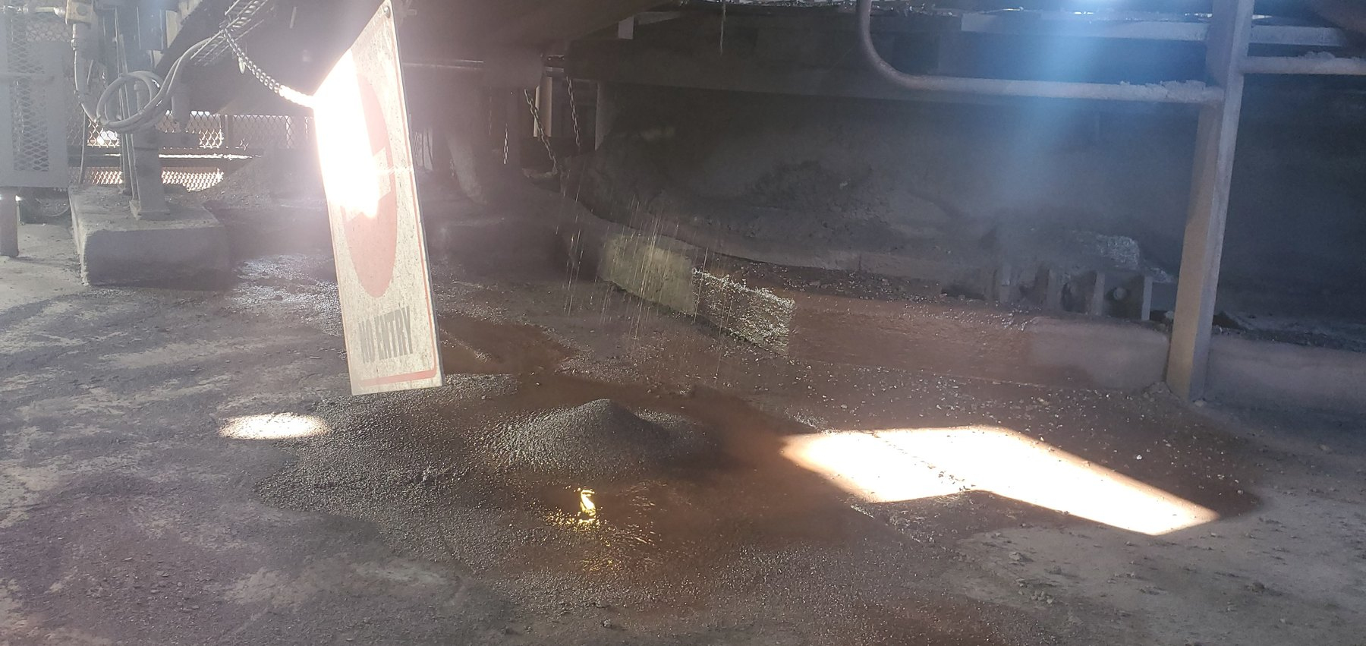  CV09-REF-002 — wet-fines/slurry consequence below the discharge/cleaner region.
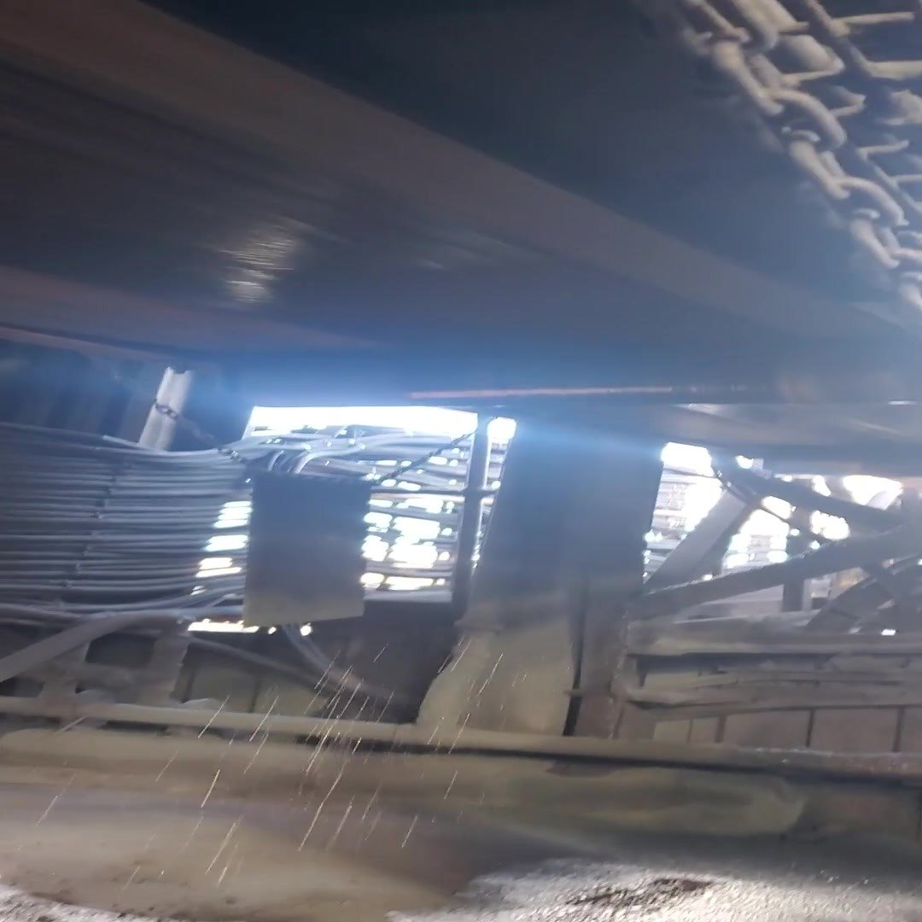  CV09-REF-006 — representative frame from inspection video showing active wet-material fallout during operation. |  | 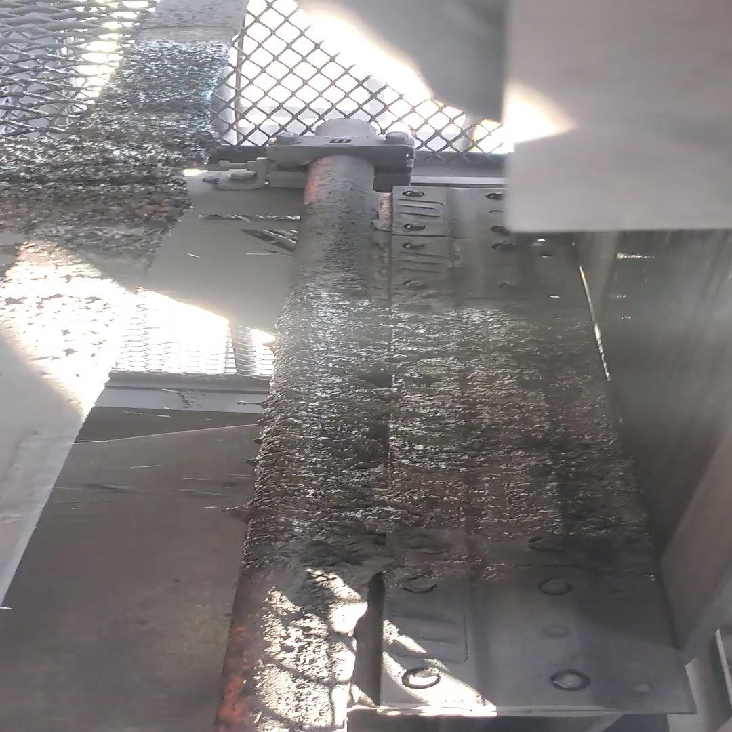  CV09-REF-008 — representative frame from inspection video showing contaminated cleaner/chute geometry relevant to the containment-boundary issue and pilot concept.
OBSERVATION | Wet fines/slurry are present below CV09 and active wet-material fallout was recorded during operation.
ENGINEERING ASSESSMENT | The cleaner removes material from the belt, but the local arrangement does not adequately retain that removed material within the intended downstream process/fines-handling route. Final cleaner type, contact pressure, chute dimensions, supports and access geometry are not defined by the present evidence.
CONTROL PHILOSOPHY | Do not merely clean the belt. Keep the fines inside the process.
RECOMMENDED NEXT ACTION | Develop and trial a CV09 cleaner/containment arrangement after verifying belt/discharge geometry, containment geometry, mounting, wear compensation, access, maintainability, safety and the downstream fines route.

9.3 What CV09 Means Beyond CV09
Taken together, CV06 and CV09 show why the mine should standardise the required material-control function rather than one identical scraper arrangement. CV06 demonstrates a compromised cleaning function, while CV09 shows that material removed from the belt can still become spillage if it is not kept inside the process. The common requirement can therefore be defined clearly while the physical hardware is adapted to the local geometry and service.

10 Cleaner / Fines-Control Philosophy and CV09 Pilot
CV09 is the preferred pilot because its operating condition, cleaner/discharge arrangement, active wet-material fallout and intended destination for removed fines can all be related to one another. The pilot should demonstrate a practical arrangement that removes residual fines effectively, maintains the cleaning function as wear and adjustment occur, and keeps the removed material within the intended process stream.
- Verify and maintain effective cleaner-to-belt contact through the agreed operating/wear range.
- Evaluate appropriate self-tensioning/wear-compensation and positive travel-limitation principles from verified site geometry.
- Provide a controlled route for cleaner-removed wet fines back into the intended chute/process stream.
- Position the cleaning function within an effective local containment arrangement so removed fines do not become plant-area spillage.
- Retain safe inspection, adjustment, blade replacement, guarding and clean-out access.
- Consider primary/secondary cleaning stages only where justified by the verified wet/sticky duty and available installation space.
STANDARDISE THE FUNCTION | This is not a recommendation to install one identical scraper at every conveyor. Prove the required cleaner/containment function at CV09, then assess each applicable location for its own mechanism, belt/material condition, chute geometry, maintenance access and safe installation space. U4 remains a geometry-specific exception.
The pilot should be judged by whether it produces a sustained improvement rather than by the appearance of the area immediately after installation. Downstream carryback should be reduced relative to the pre-trial condition, removed wet fines should remain in the process, cleaner contact should remain stable through the agreed wear condition, and no unacceptable belt wear, cleaner wear, guarding, trapping or maintenance-access problem should be introduced. The monitoring record should also be sufficient to decide whether the same functional approach is worth assessing at other locations.
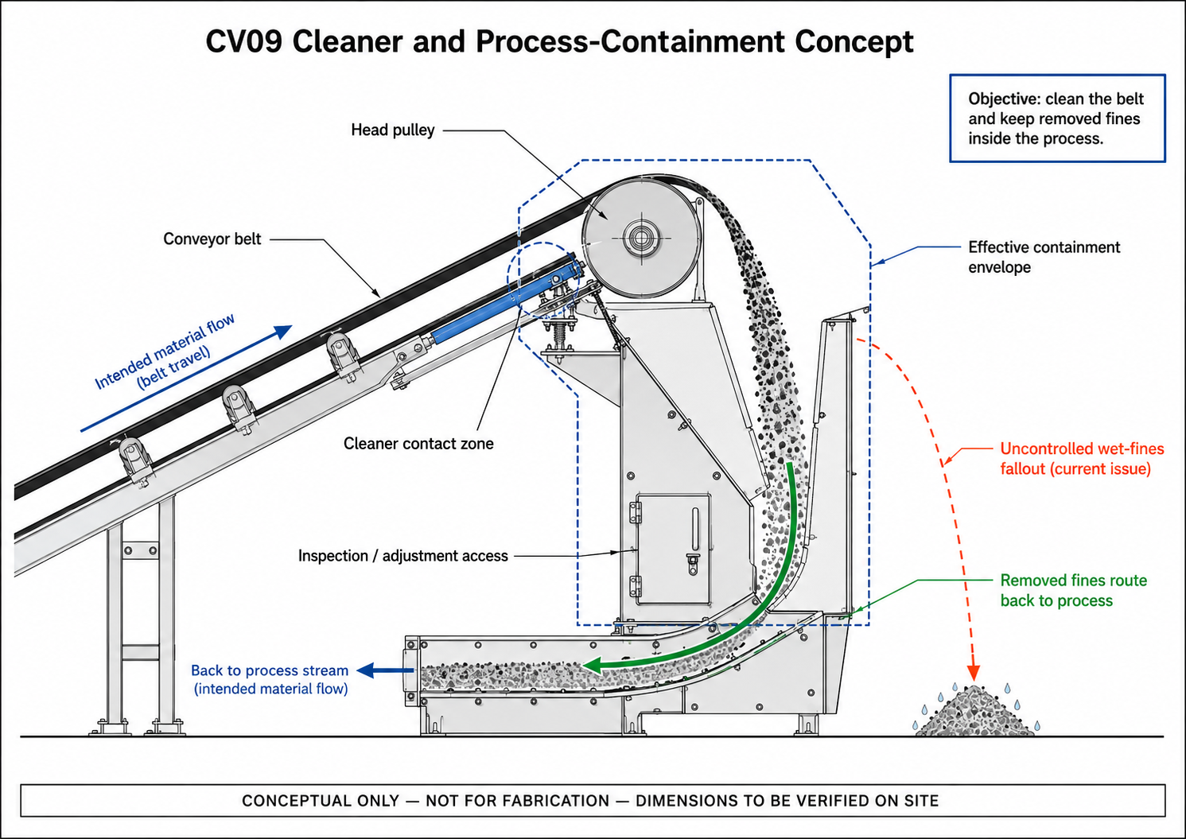
CTD-001 — CV09 Cleaner and Process-Containment Concept. Conceptual only; not for fabrication; dimensions to be verified on site.
PART V — COARSE / COMBINED-PRODUCT LOSS DURING TRANSIT

11 The Containment Problem Is Not Limited to Fines
The inspection also identified locations where coarse/lump or mixed product had left the carrying belt during transit. These conditions are different from return-side fines/carryback and require a separate control approach focused on keeping product within the usable carrying area of the belt until the intended transfer or discharge. Depending on the location, the relevant factors may include feed quantity and product size, loading trajectory, usable belt width, mistracking, transfer geometry and local side containment.
The preferred sequence is to understand the loss mechanism and verify the feed and geometry first, correct the primary contributors where practicable, and then determine whether any residual side-containment duty remains. Secondary skirts, rails or barriers should therefore complement the primary correction rather than conceal an unresolved source condition.

12 W10 — Coarse Product Loss in a Confined Tunnel
W10 is significant because substantial coarse/mixed-product accumulation is present outside the intended belt path in a confined tunnel. The photographs clearly establish the consequence and the restricted access geometry, but they do not isolate one definitive initiating cause for every deposit. A local barrier or rail can therefore be considered as a secondary containment concept, provided the underlying loading, tracking and geometry are checked first.
What is established is that product has left the intended carrying path and entered a restricted access zone. In this geometry, the consequence is greater because escaped product occupies limited access space and creates repeated recovery and housekeeping demand. Before a barrier is detailed, the normal belt tracking envelope, local trough/belt/support geometry, available clearances, likely source contributors and clean-out/maintenance access should be verified. If a barrier remains justified after that review, it should remain clear of the belt during normal operation and should not introduce new trapping, wear or access hazards.
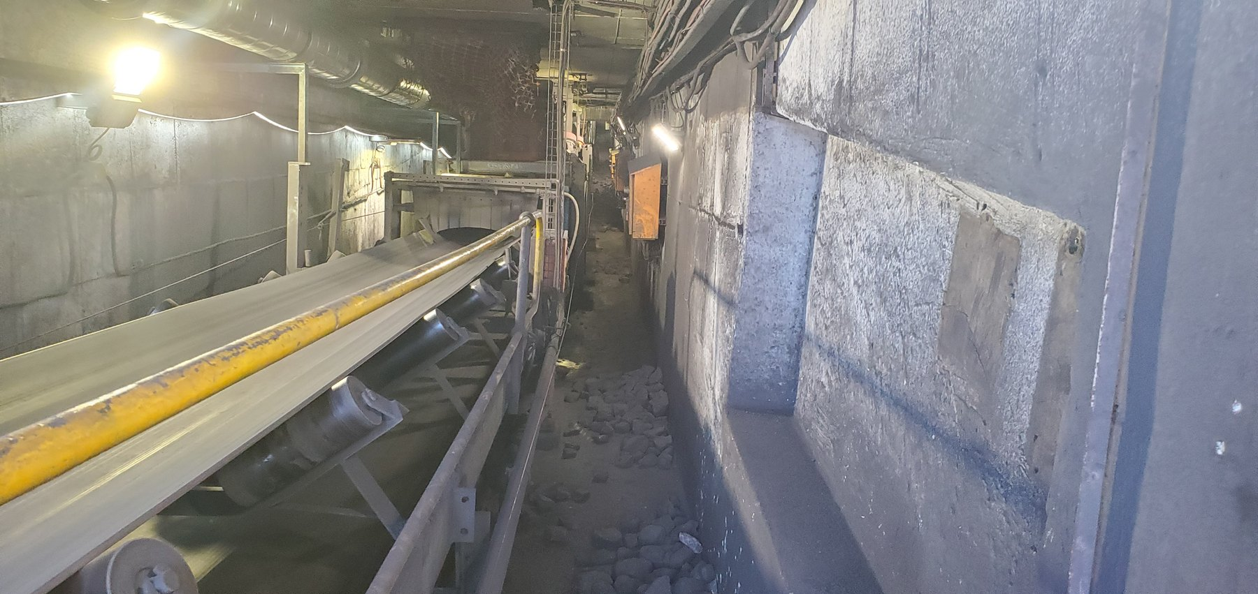  W10-REF-010 — long tunnel view establishing the confined topology and restricted access. |  |   W10-REF-002 — principal coarse/mixed-product consequence in the access route.
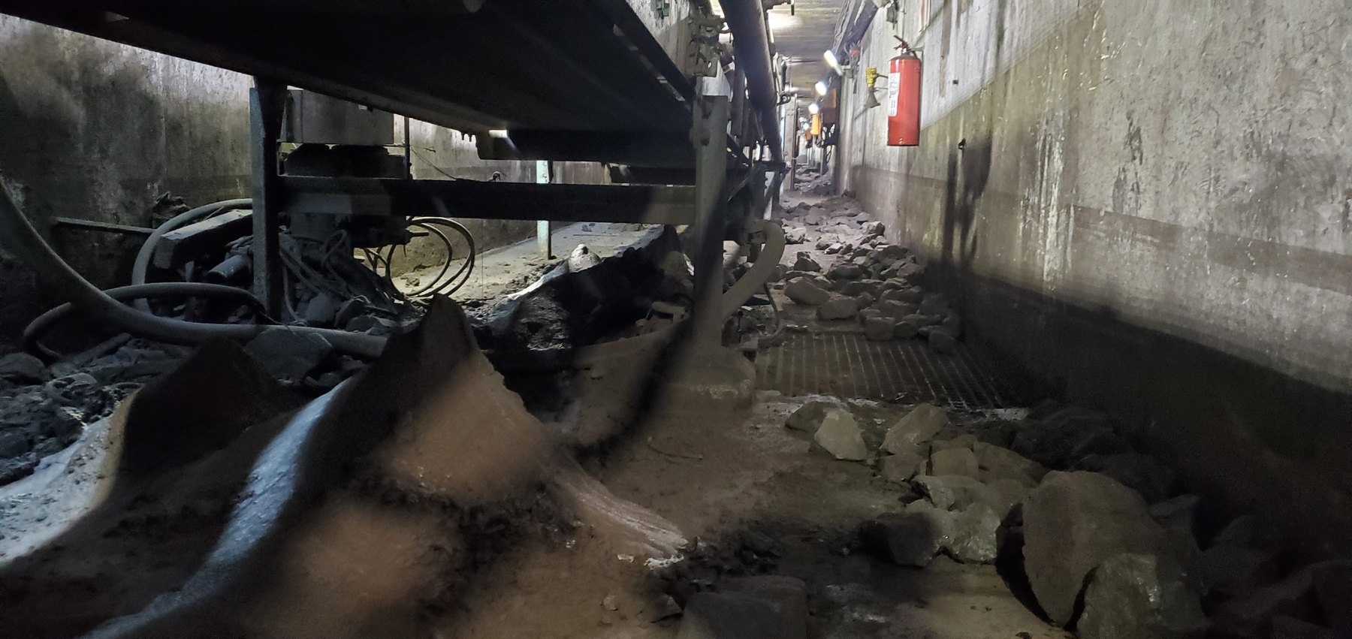  W10-REF-006 — product distributed below the conveyor around components, explaining local geometry. |  | 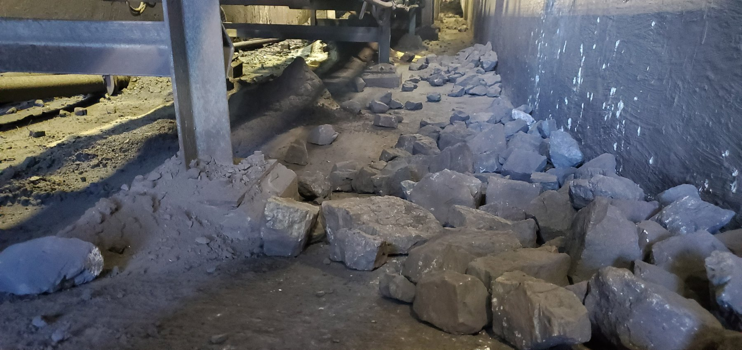  W10-REF-009 — product immediately beside support steel; useful context for local side-containment feasibility.
OBSERVATION | Coarse/mixed product has escaped the intended carrying path and accumulated in a confined access tunnel.
ENGINEERING ASSESSMENT | The exact initiating mechanism remains unresolved. The local barrier/rail concept is a secondary control to be considered only after tracking, loading, trough/support geometry and source-control opportunities are checked.
RECOMMENDED NEXT ACTION | Establish the normal tracking envelope and geometry, investigate source contributors, then develop a local barrier/rail only if a residual containment duty remains. Verify representative operating clearance, access, trapping, wear and maintenance requirements before close-out.
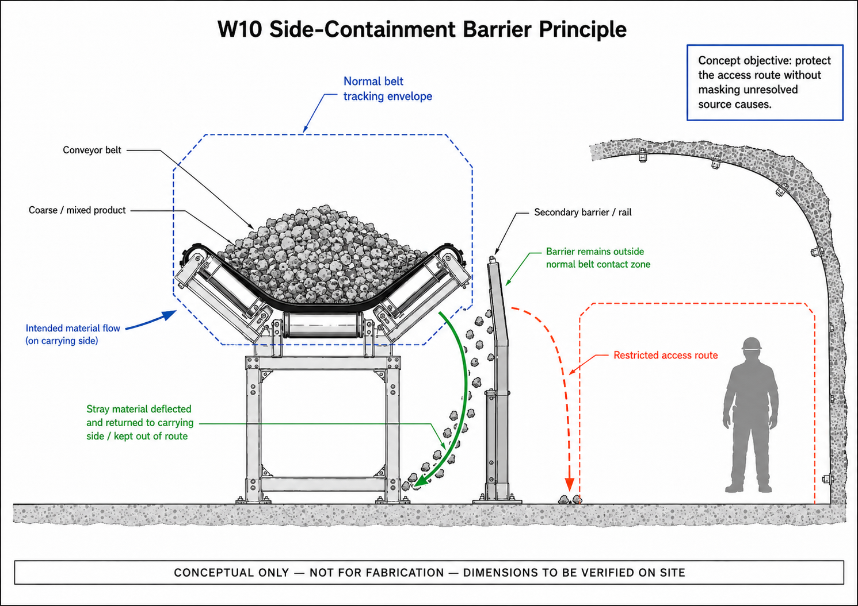
CTD-002 — W10 Side-Containment Barrier Principle. Secondary concept only; not for fabrication; dimensions and tracking envelope to be verified.

13 Sample Conveyors — Product Size, Feed and Limited Carrying Width
Sample Conveyors 2 and 3 show another form of coarse-product containment pressure. Large product occupies a substantial proportion of the relatively narrow belt carrying width. Although the visible consequences are similar, the evidence does not support exactly the same conclusion at both conveyors. The first engineering question is therefore whether the representative product size, incoming quantity and feed trajectory are appropriate for the usable carrying width at each location.
CONTROL HIERARCHY | 1. Verify/control incoming feed and product condition. 2. Measure usable belt width and carrying margin. 3. Verify/correct tracking and mechanical contributors. 4. Apply secondary containment only if a residual duty remains.

13.1 Sample Conveyor 2
At Sample Conveyor 2 the loading/containment concern is directly supported, with coarse/lump product occupying a substantial proportion of the narrow belt and material visible outside the intended carrying path. Significant mistracking is not established by the still evidence, and the photographs do not prove quantitative design-capacity overload. Feed quantity, product-size distribution, trajectory, usable belt width and live tracking should therefore be checked before final side containment is specified.
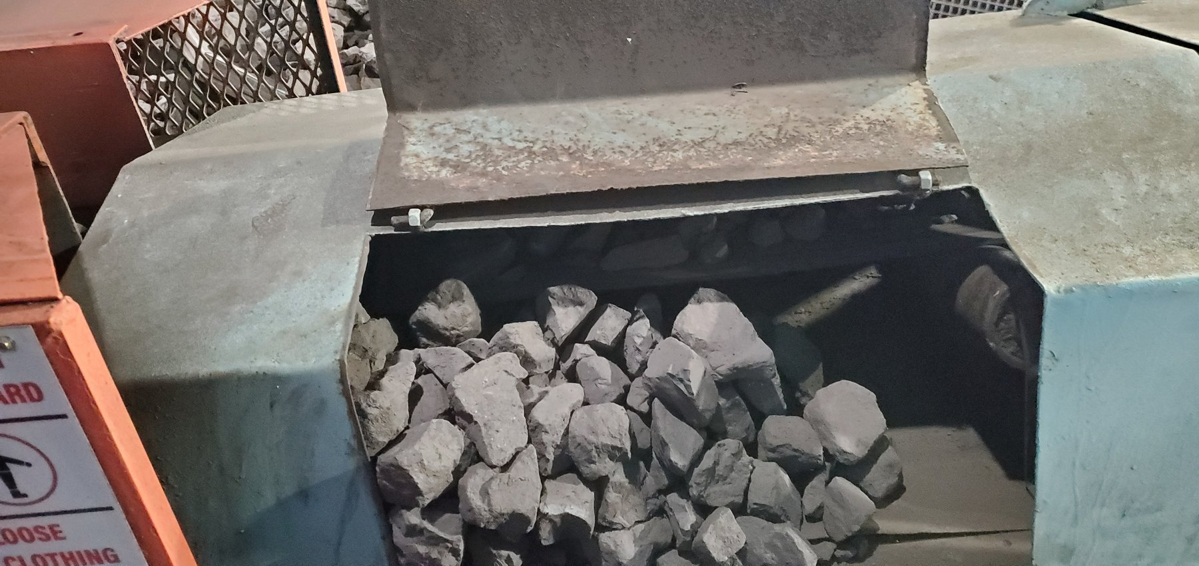  LoadoutStationSample2-REF-004 — coarse product occupying a substantial proportion of the narrow belt width. | 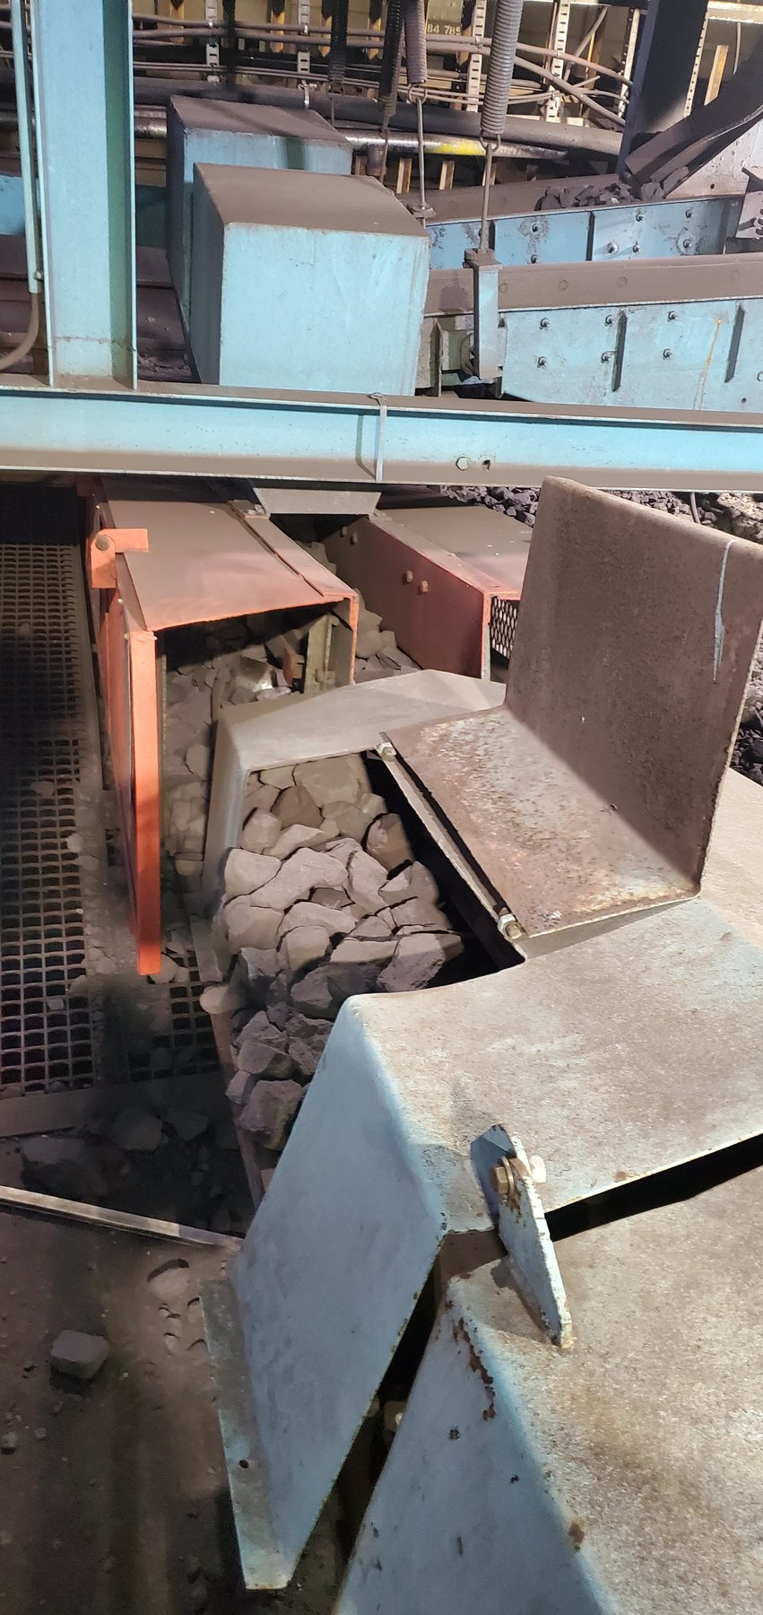  LoadoutStationSample2-REF-006 — product accumulated through/around the local enclosure and outside the intended carrying path. | 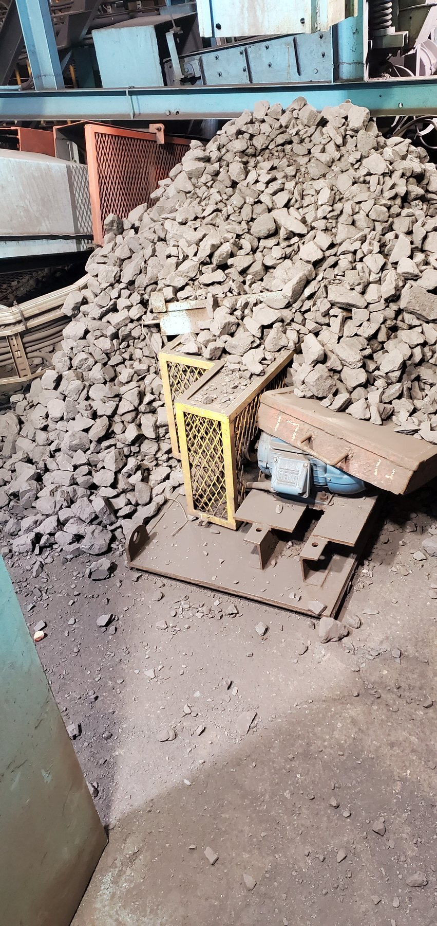  LoadoutStationSample2-REF-001 — extensive surrounding lump-product accumulation.
The recommended response is to establish the actual feed-control or metering arrangement, observe representative loading, measure the usable belt width and normal edge clearance, and check live tracking without presuming a tracking fault. Secondary support, skirt or rail geometry should only be developed once those primary conditions are understood.

13.2 Sample Conveyor 3
Sample Conveyor 3 combines the same narrow-belt/product-size containment pressure with visually supported lateral belt offset/mistracking. The offset magnitude remains unmeasured and the photographs do not establish the mechanical root cause. The appropriate response is therefore to verify the feed/loading condition and measure the tracking/alignment geometry before any final secondary containment is selected.
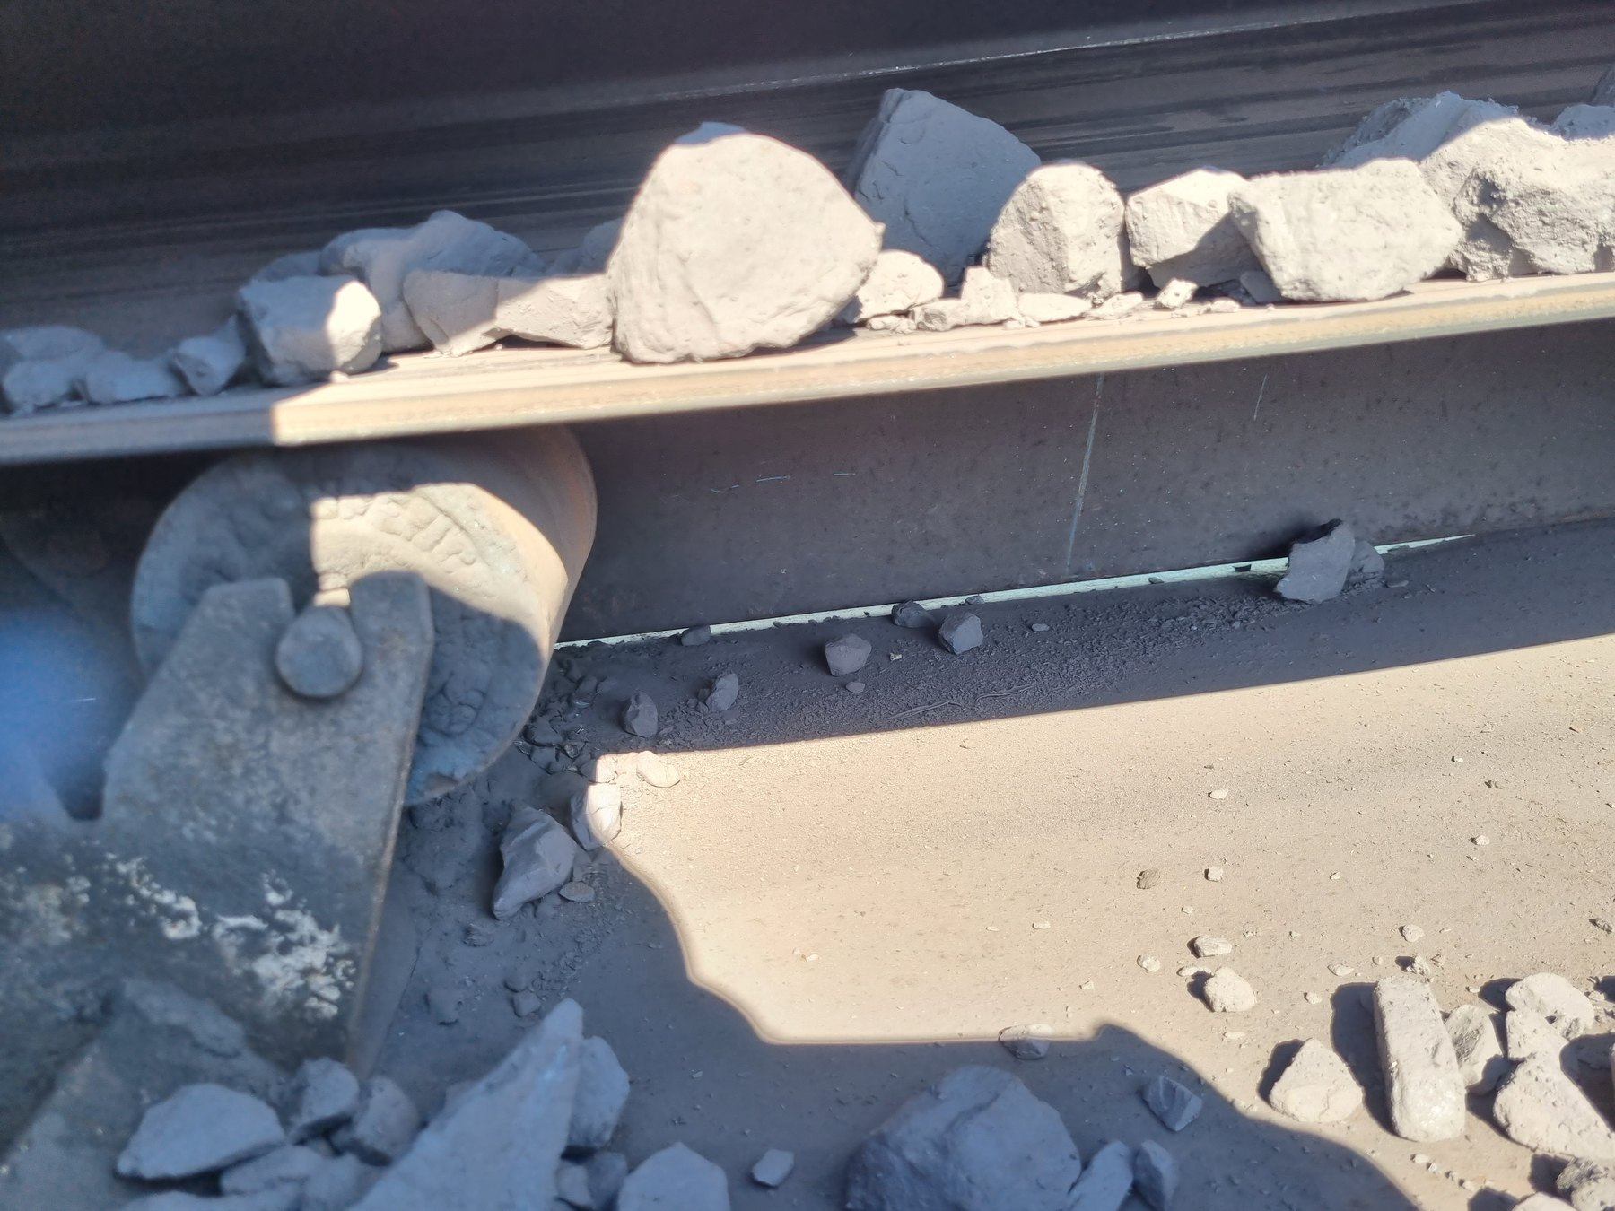  LoadoutStationSample3-REF-005 — large lumps occupying much of the available narrow belt width. |  | 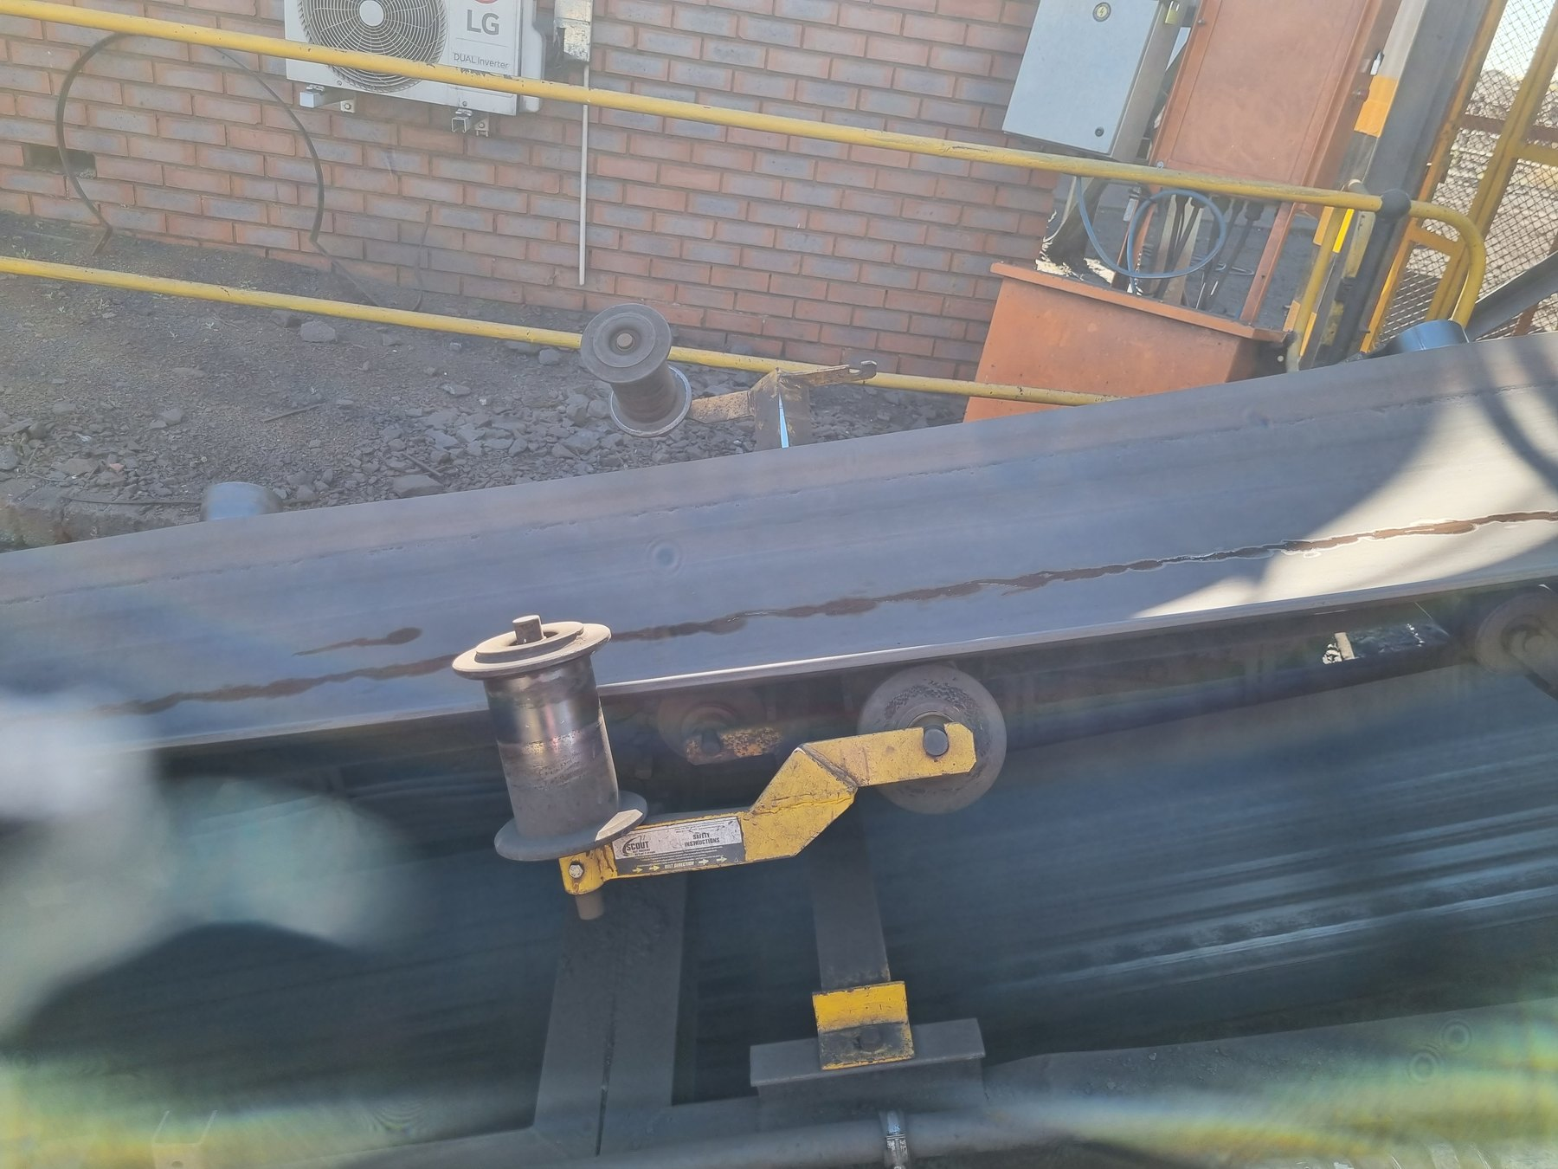  LoadoutStationSample3-REF-013 — strongest still supporting lateral belt offset relative to the training/guide arrangement.
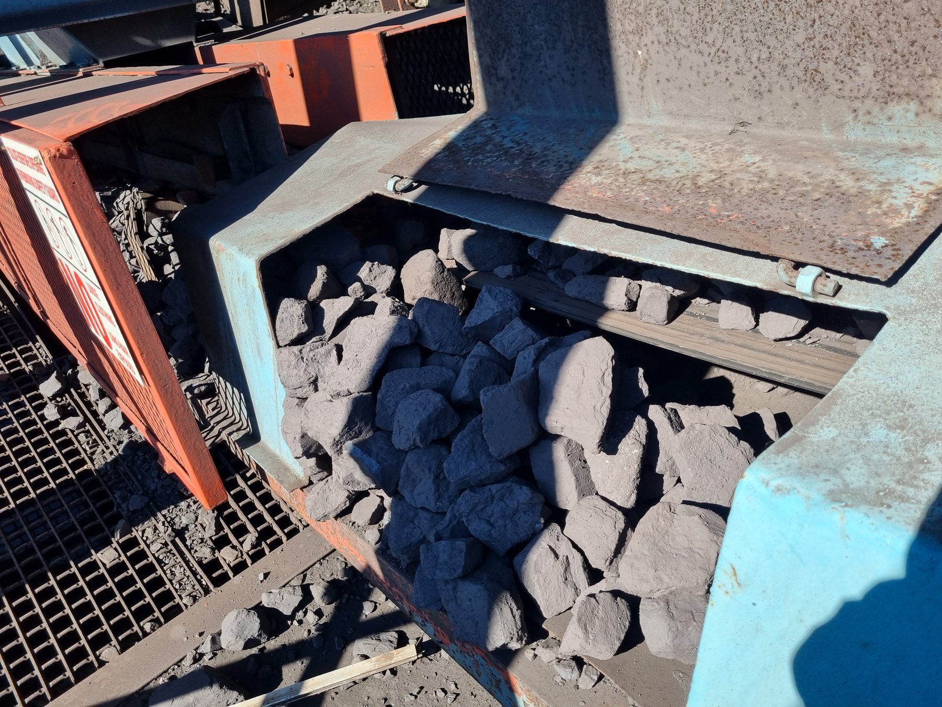  LoadoutStationSample3-REF-002 — coarse product accumulated around/outside the intended belt path. |  | 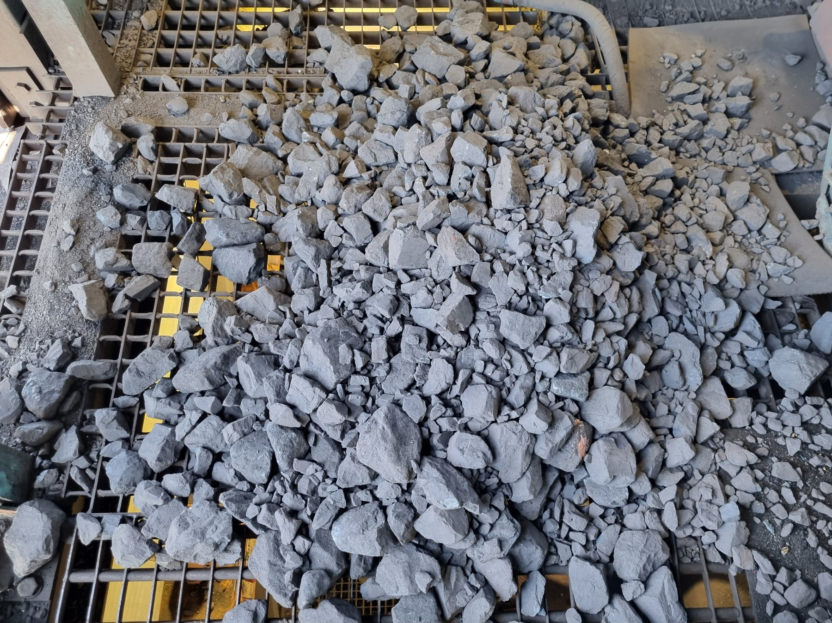  LoadoutStationSample3-REF-012 — extensive mixed-size accumulation on surrounding grating/access.
OBSERVATION | Product-size/available-width pressure and significant surrounding spillage are visually established; lateral offset/mistracking is also visually supported.
ENGINEERING ASSESSMENT | The evidence does not justify a measured percentage or millimetre offset, and it does not prove whether head/tail alignment, tension, trapped material or another mechanical condition is the root cause.
RECOMMENDED NEXT ACTION | Control feed/load, measure and correct tracking/alignment under representative operation, then develop secondary side-containment only where required by the verified geometry.
Question | Sample Conveyor 2 | Sample Conveyor 3
Loading / carrying-width concern | Supported | Supported
Significant mistracking established by current evidence | No | Yes — visually supported
Offset magnitude measured | N/A / not established | No — measurement required
Primary next step | Verify feed, width and live tracking | Verify feed + quantify/correct tracking
Secondary containment | Only after feed/tracking condition established | Only after feed/tracking correction and residual duty confirmed
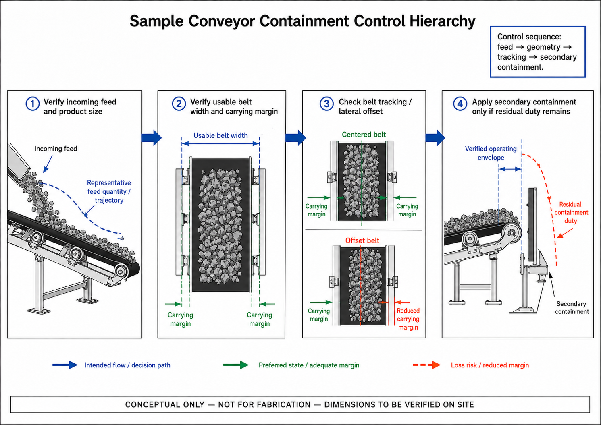
CTD-003 — Sample Conveyor Containment-Control Hierarchy. Conceptual only; not for fabrication; site geometry to be verified.
PART VI — ALIGNMENT AND LOCAL PRODUCT-LOSS MECHANISMS

14 Belt Tracking as a Material-Containment Requirement
A carrying belt can use its full containment margin only when it remains suitably centred relative to the supporting structure. Lateral displacement reduces the usable carrying margin on one side and can expose coarse/mixed product to the edge of the usable carrying area. Tracking is therefore both a mechanical condition and an important part of material containment.

15 U4 Tripper Car — Strong Local Cause-and-Effect Example
U4 provides one of the clearest local cases in which significant lateral belt offset/mistracking and one-sided product loss are both supported by the evidence. Tail-pulley misalignment was recorded during the inspection and is visually supported, but the magnitude was not measured against a fixed survey reference. This makes quantitative alignment and full-travel operating checks an important part of the corrective work.
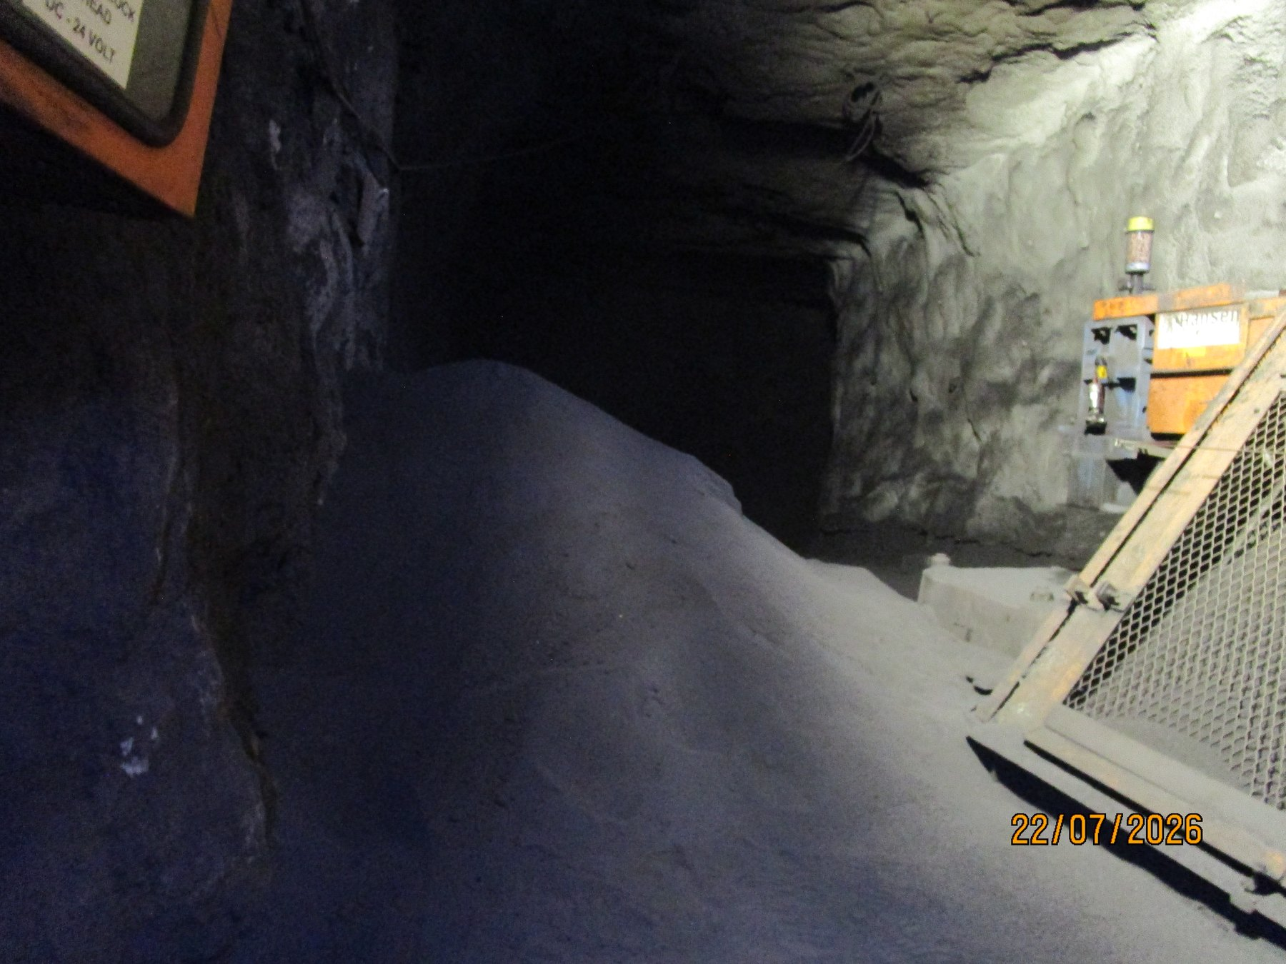  UGU4-REF-006 — principal local product-loss / mistracking context. |  | 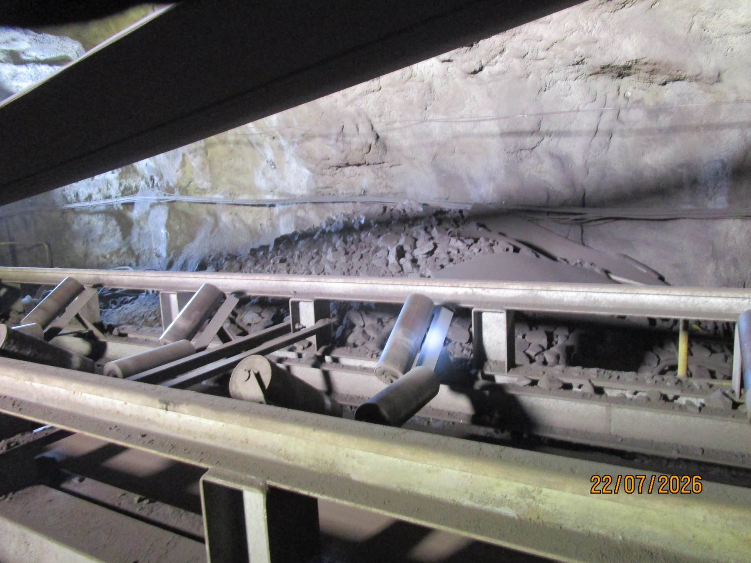  UGU4-REF-007 — significant lateral belt position and local material condition.
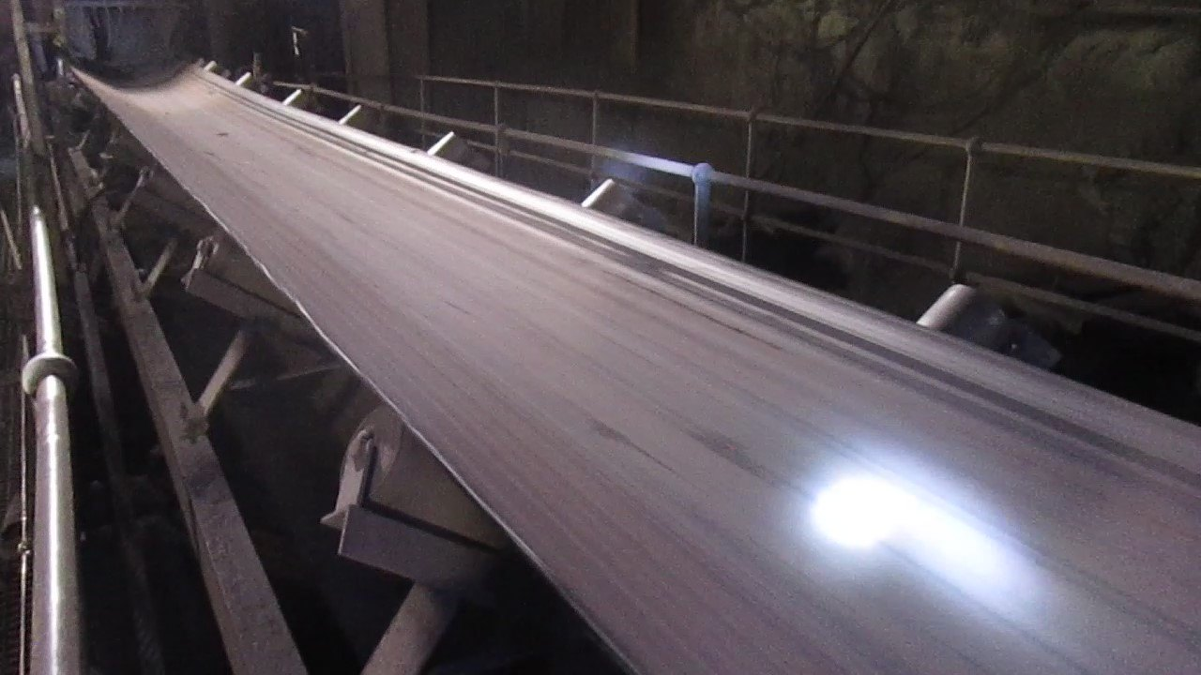  UGU4-REF-009 — supporting belt/roller relationship. |  | 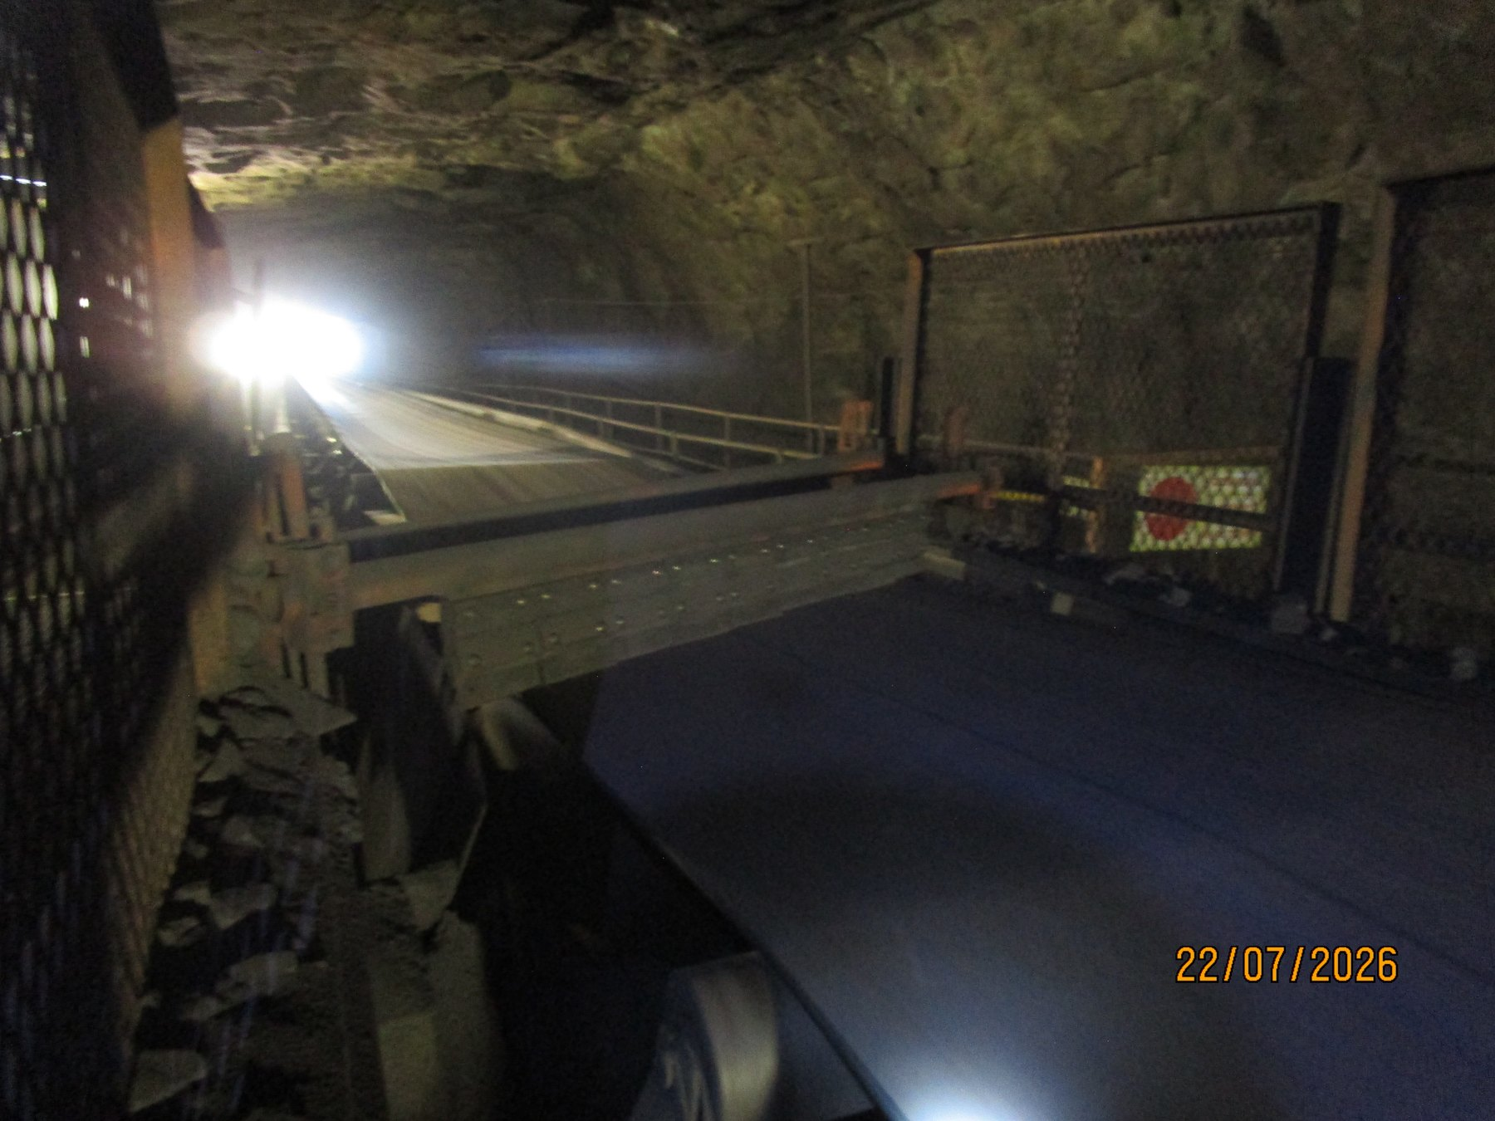  UGU4-REF-011 — strong local consequence / accumulation evidence.
OBSERVATION | Mistracking and one-side product loss are visually verified at U4.
ENGINEERING ASSESSMENT | Tail-pulley misalignment remains unquantified. The local cleaner arrangement is materially different from CV09 and must not receive a generic replicated solution.
RECOMMENDED NEXT ACTION | Quantitatively verify/realign relevant pulley geometry, check tracking through representative operation and full tripper travel, and assess the U4 cleaner/containment configuration separately.

16 L3 — Alignment Concern Without Proven Solid-Product Causal Chain
L3 is included deliberately as a contrast to U4. The tail-end belt/pulley offset is supported by the evidence, but the current record does not establish that the offset is causing significant solid/lump-product loss. The local fines/carryback condition should therefore remain separate from the alignment concern until measurement and representative operation provide a stronger basis for any causal conclusion.
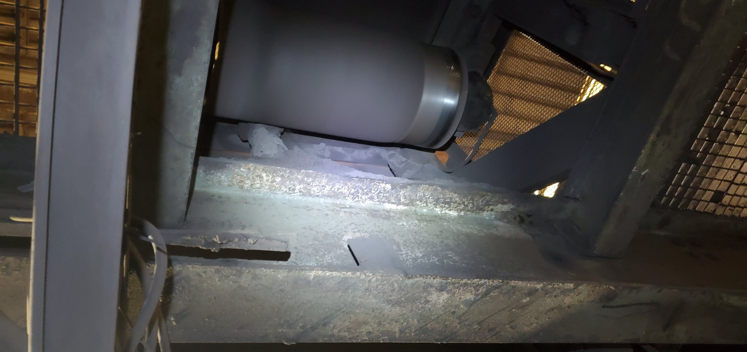  LoadoutStationL3-REF-001 — tail-end asymmetric belt/pulley relationship supporting the recorded offset; quantitative alignment measurement remains required. | 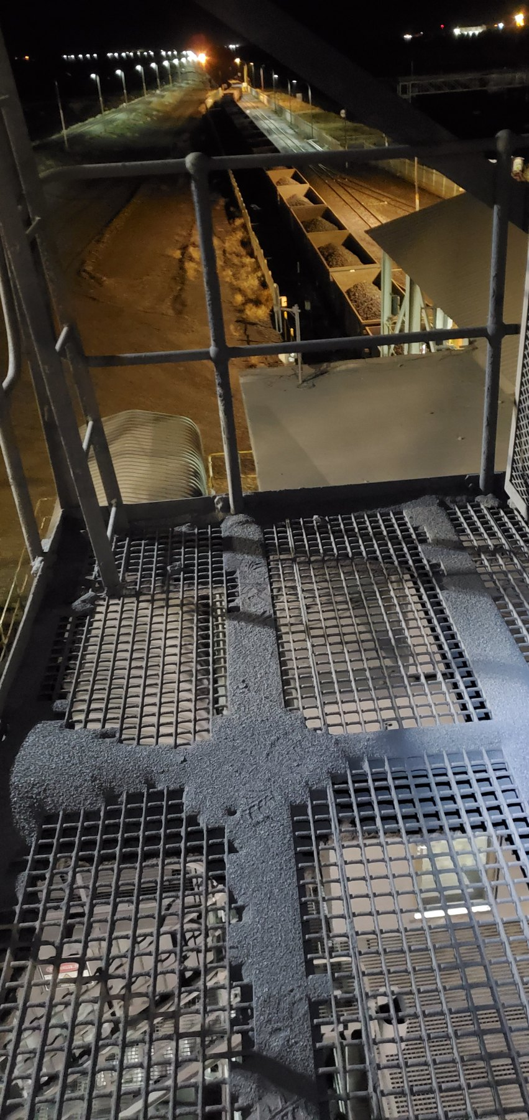  LoadoutStationL3-REF-007 — fine-material accumulation on guarding/adjacent structure.
EVIDENCE DISCIPLINE | A mechanical alignment finding becomes a material-loss conclusion only to the extent that the evidence supports the connection. U4 supports tracking plus directional product loss; L3 presently supports an alignment/offset concern requiring quantitative verification.
Evidence question | U4 | L3
Offset / tracking concern supported | Yes | Yes
Alignment magnitude measured | No | No
Directional significant coarse-product loss linked | Strongly supported | Not established
Close-out | Measure, correct, prove full-travel tracking | Measure, correct/disposition, observe live tracking and local consequence
PART VII — WATER, WET FINES AND STRUCTURAL CONSEQUENCES

17 Water as a Material-Transport and Deterioration Mechanism
Water introduces a different containment problem. When process or cleaning water leaves the intended process path, it can mobilise fines, create slurry, spread contamination away from the source, increase slip and housekeeping burden, and repeatedly wet surrounding equipment and structures. Not every wet deposit proves the same water source, so each location is considered according to the evidence available there.
The report therefore distinguishes directly observed process-water escape from locations where water or wet fines are visible but the initiating source remains unresolved. Water containment and structural condition are also treated as related but separate issues: repeated wetting may be relevant to deterioration, but the photographs do not establish water as the cause of every structural defect.
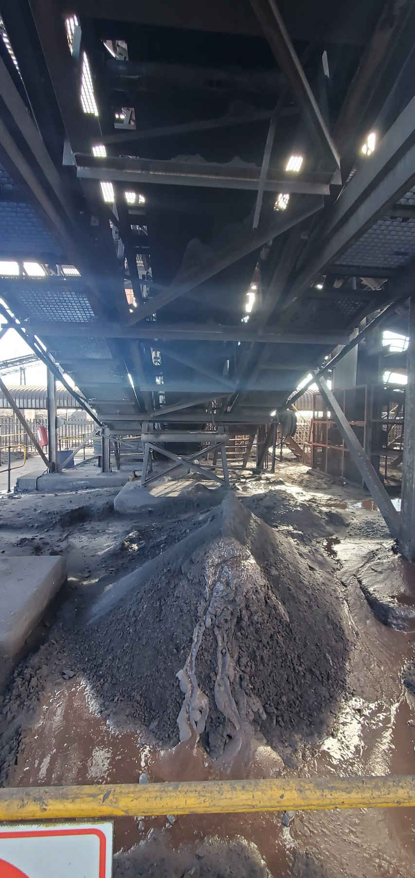  CV01-REF-003 — principal wet-fines/slurry consequence with pooled water/slurry; exact water source unresolved. |   CV04-REF-002 — saturated wet-fines/slurry with visible wet fallout/droplets. | 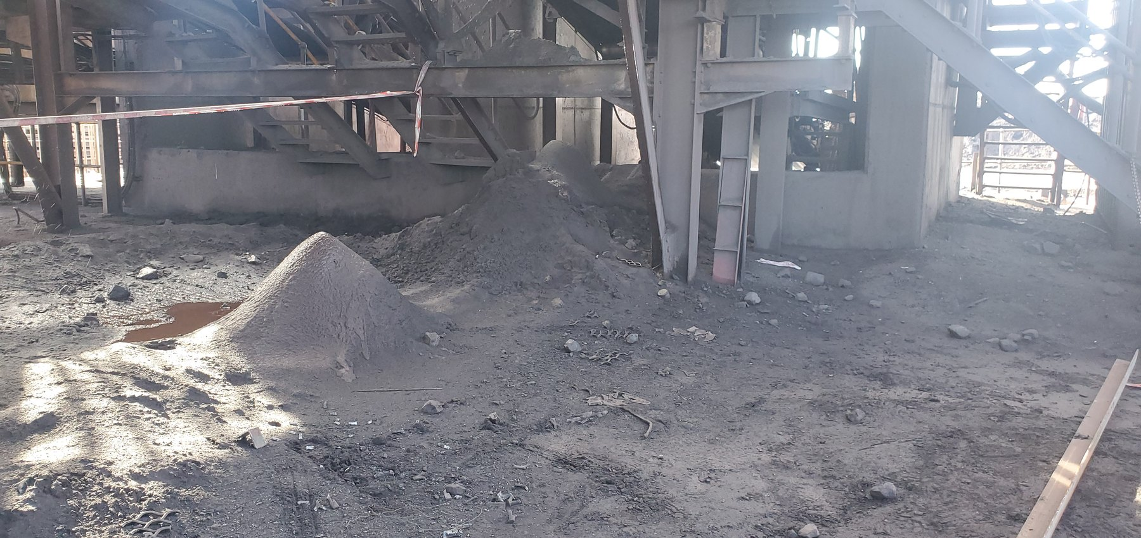  CV04-REF-005 — wider extent of multiple fines piles supporting the widespread CV04 condition.

18 Screens — Confirmed Water Escape / Separate Structural Story
The Screens evidence contains three related but distinct stories: active process-water loss of containment, severe corrosion/deterioration, and physical cut-outs or notches in support members. Video evidence directly confirms active water escaping the operating screen/chute environment. The exact equipment-level escape path could not be safely established during operation and should therefore be investigated during a controlled shutdown before a detailed modification is specified.
The structural condition requires a separate competent assessment. The reason for the cut/notched supports is not established by the available evidence, and remaining structural capacity cannot be determined from photographs. Member dimensions, cut/notch geometry, section loss, connection condition and the required repair or replacement should therefore be established by the responsible structural authority.
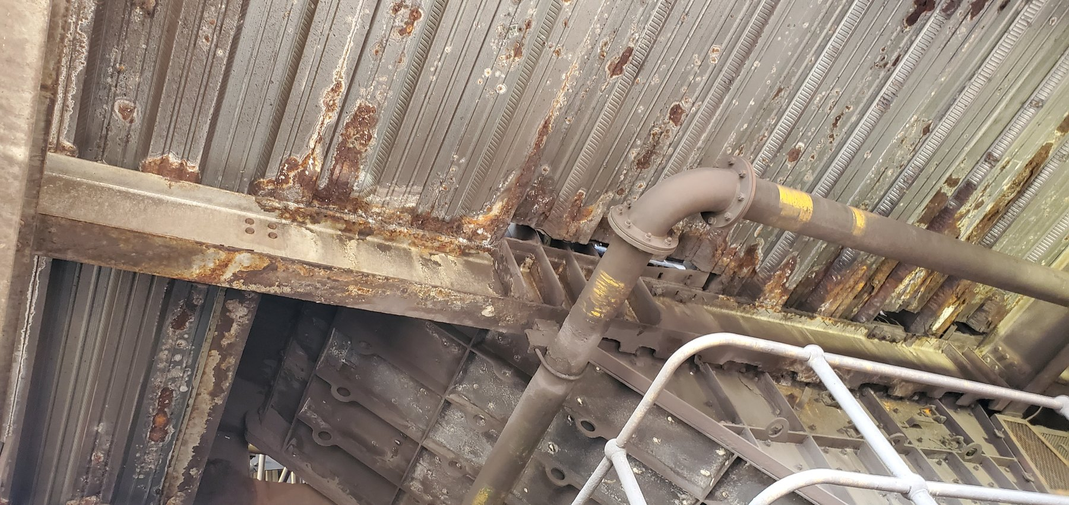  Screen-REF-003 — wider screen/chute orientation and structural zone. |  | 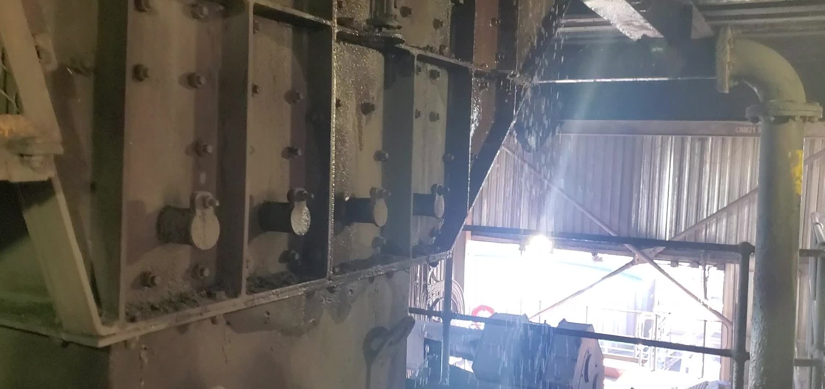  Screen-REF-016 — representative frame from inspection video showing active water spray/droplets escaping containment.
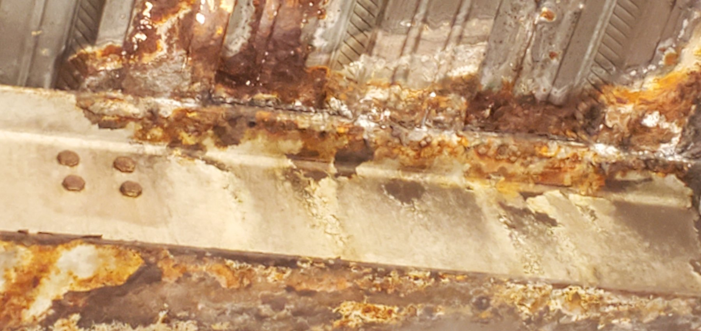  Screen-REF-004 — principal close corrosion/deterioration evidence. |  | 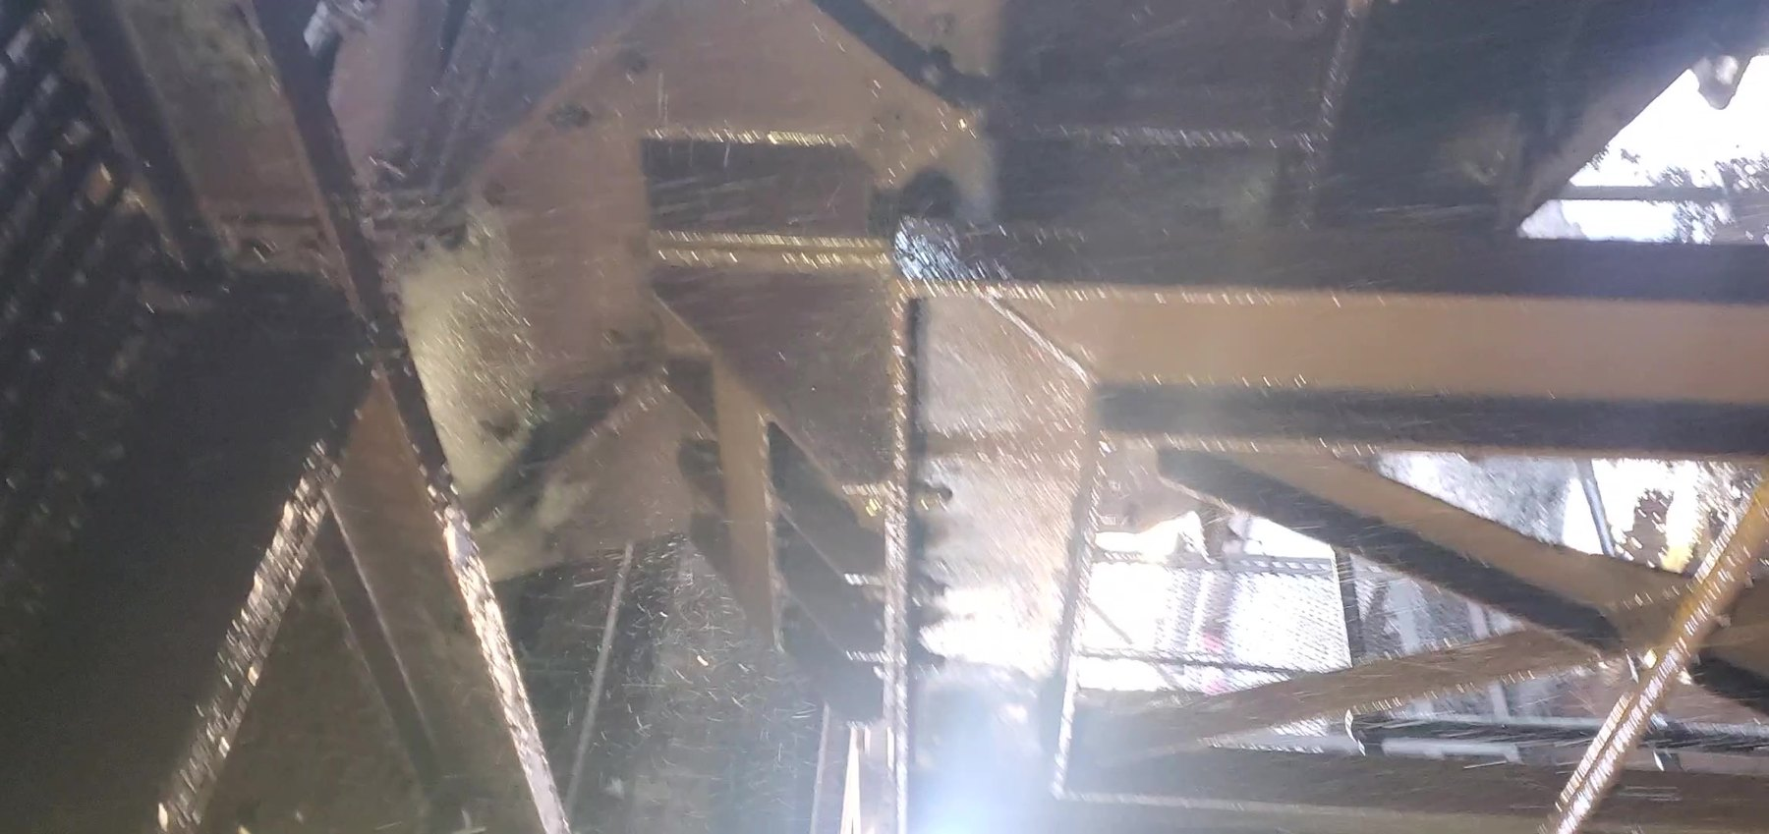  Screen-REF-017 — representative frame from inspection video showing wider substantial water spray/runoff and repeated wetting.
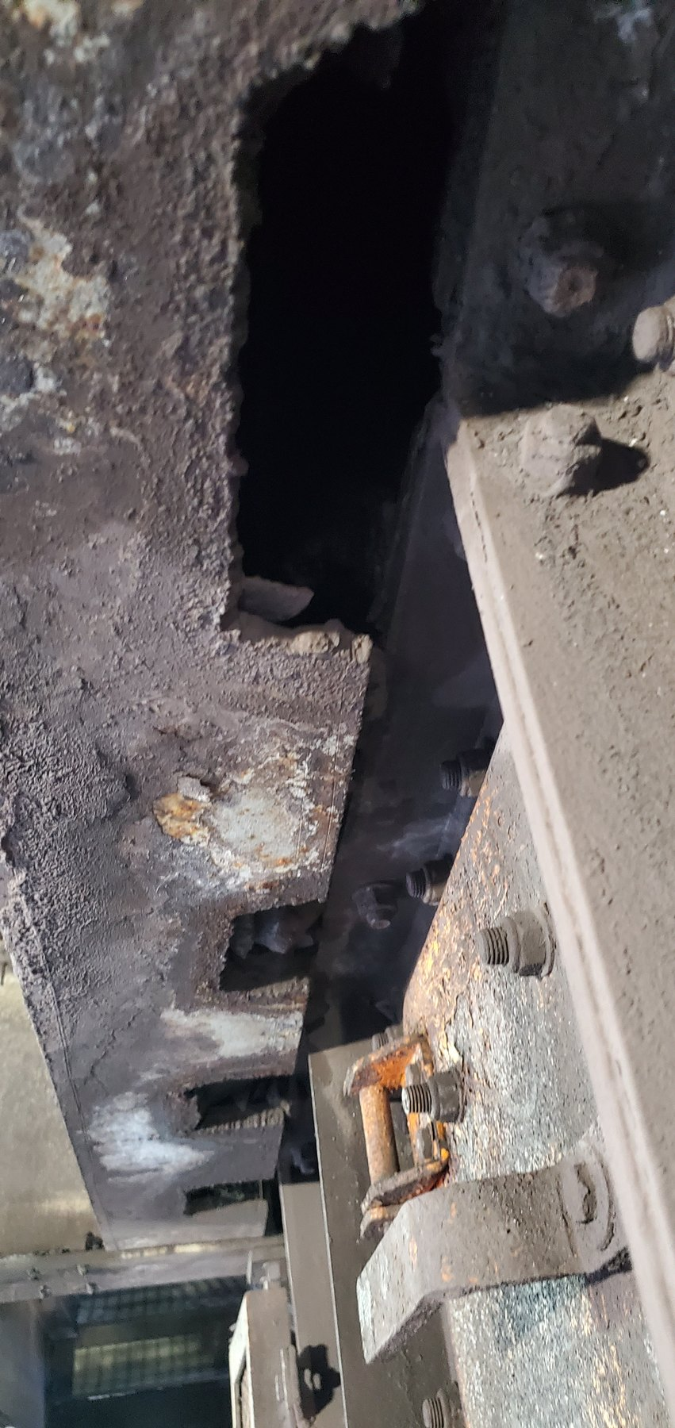  Screen-REF-006 — multiple support-member cut-outs/notches. |  | 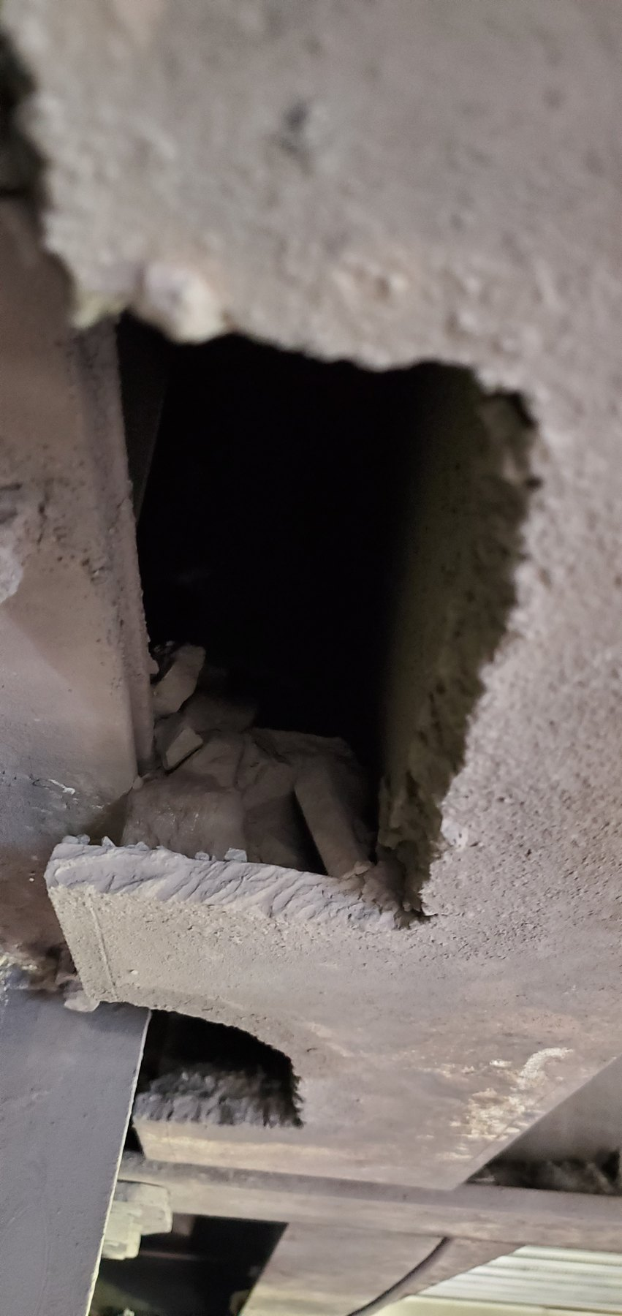  Screen-REF-010 — close evidence of a substantial support-member cut-out.
OBSERVATION | Active water escape is directly verified. Severe corrosion/deterioration and physical support-member cut-outs are also directly visible.
ENGINEERING ASSESSMENT | The equipment-level water source/escape mechanism remains unresolved. The reason for the cut-outs and the remaining structural capacity are not established. Water should not be asserted as the cause of every structural defect.
RECOMMENDED NEXT ACTION | Complete a safe shutdown inspection to identify the water escape mechanism and perform a formal structural assessment of the affected support members, including the cut/notched and corroded sections.

19 L1 — Spillage, Historical Belt Contact and Structural Deterioration
L1 contains several related but separate findings: extensive material/fines accumulation, physical evidence that the belt has previously or intermittently contacted adjacent supports, significant concrete deterioration/spalling with exposed reinforcement, and severe local steel deterioration/section loss at more than one support location.
The photographed running belt is clear of the worn supports at the captured instant, so continuous present contact is not demonstrated. The recommended response is therefore to verify tracking and clearance under representative operation, complete a competent structural assessment of the affected concrete and steel, and reduce recurring fines/moisture exposure around the repaired interfaces.
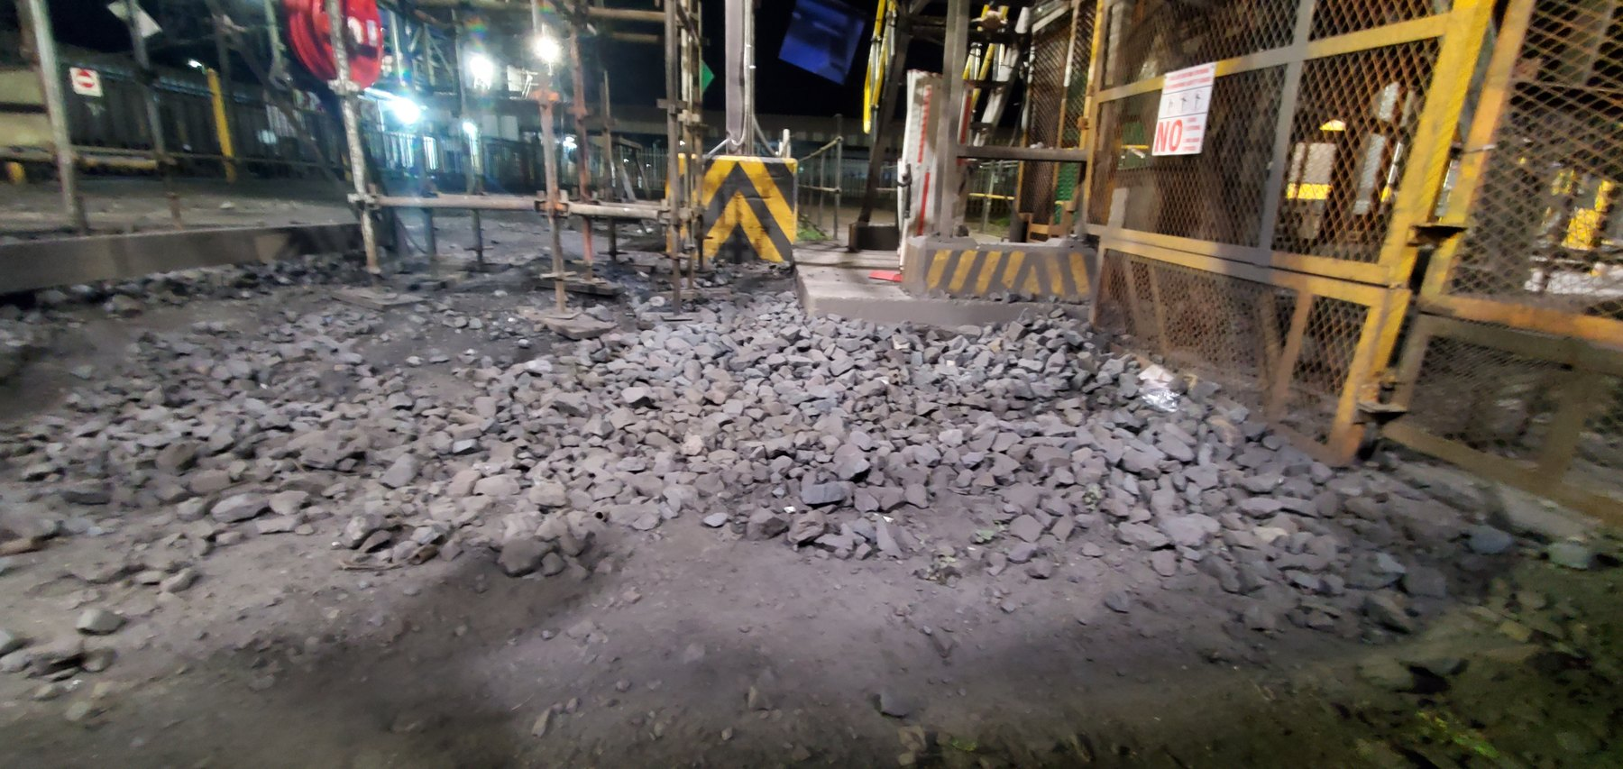
LoadoutStationL1-REF-013 — principal evidence of extensive long-term material/fines accumulation along the L1 conveyor zone.
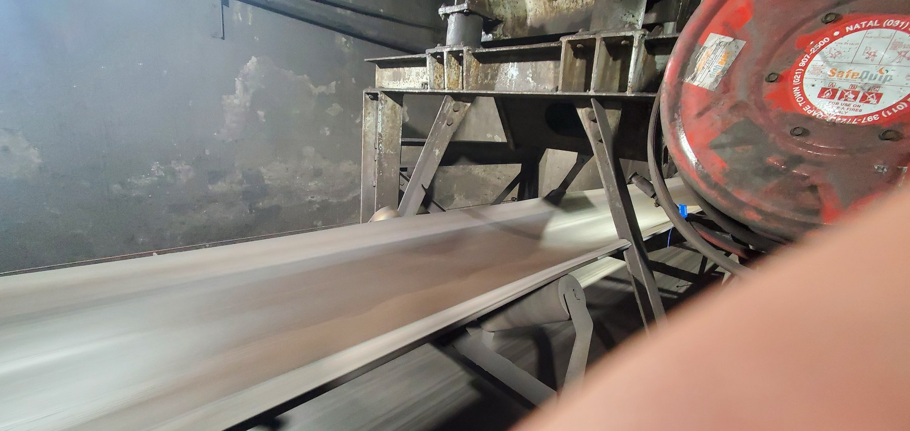  LoadoutStationL1-REF-007 — historical wear slots beside a currently clear running belt; establishes prior/intermittent contact without proving continuous present contact. | 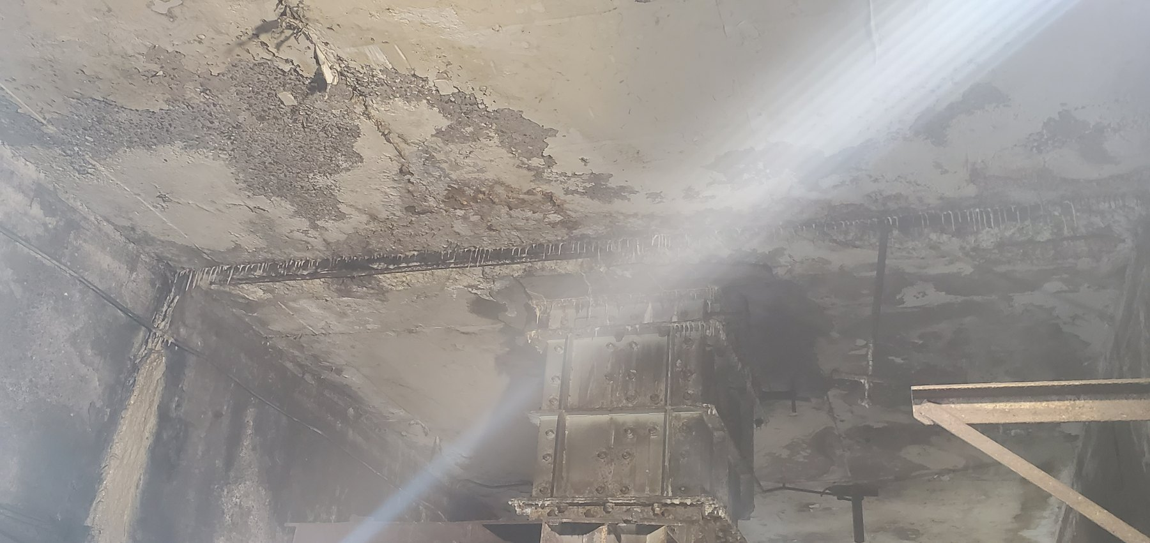  LoadoutStationL1-REF-004 — location/context for concrete deterioration. | 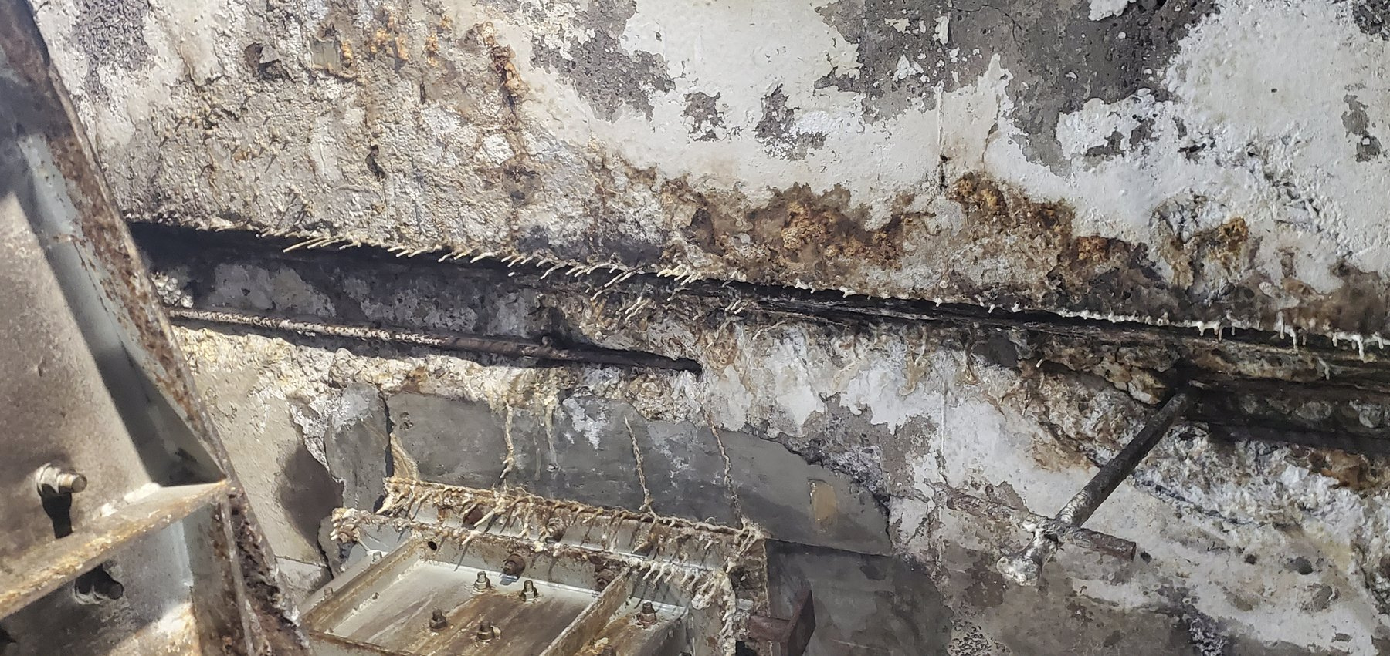  LoadoutStationL1-REF-005 — close severity of concrete loss and exposed reinforcement.
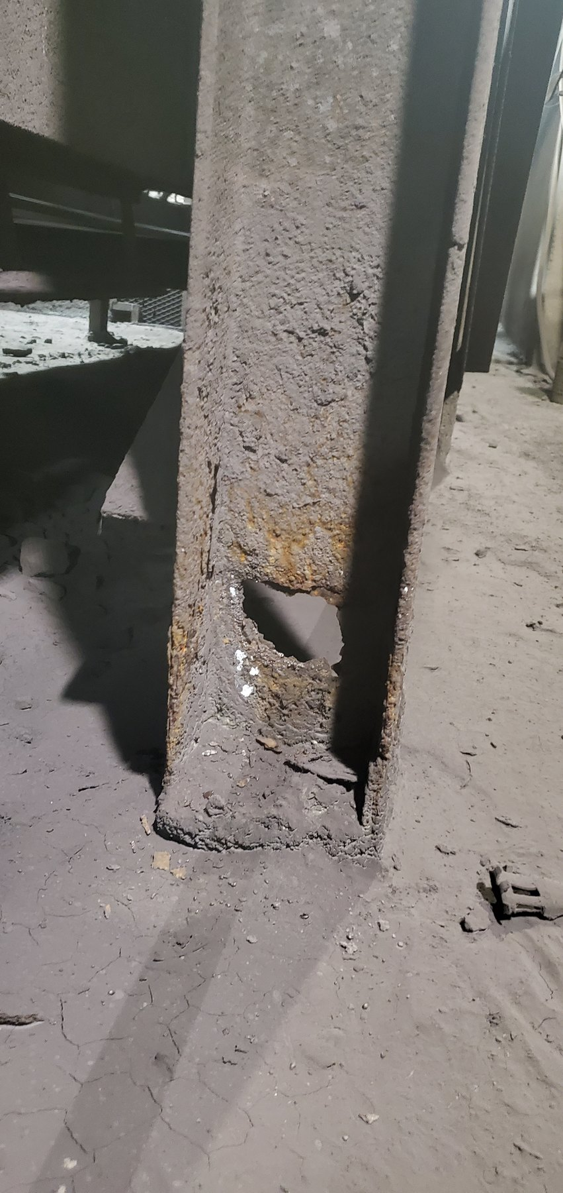  LoadoutStationL1-REF-008 — severe steel deterioration at one conveyor support location. | 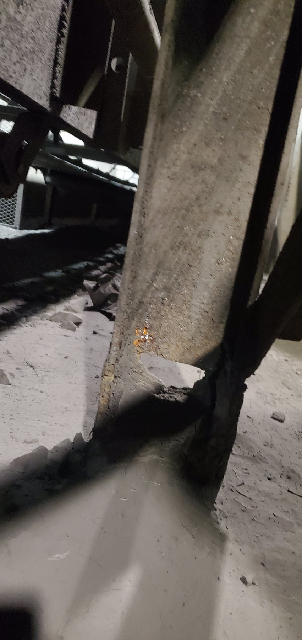  LoadoutStationL1-REF-009 — deterioration at a separate adjacent support location. | 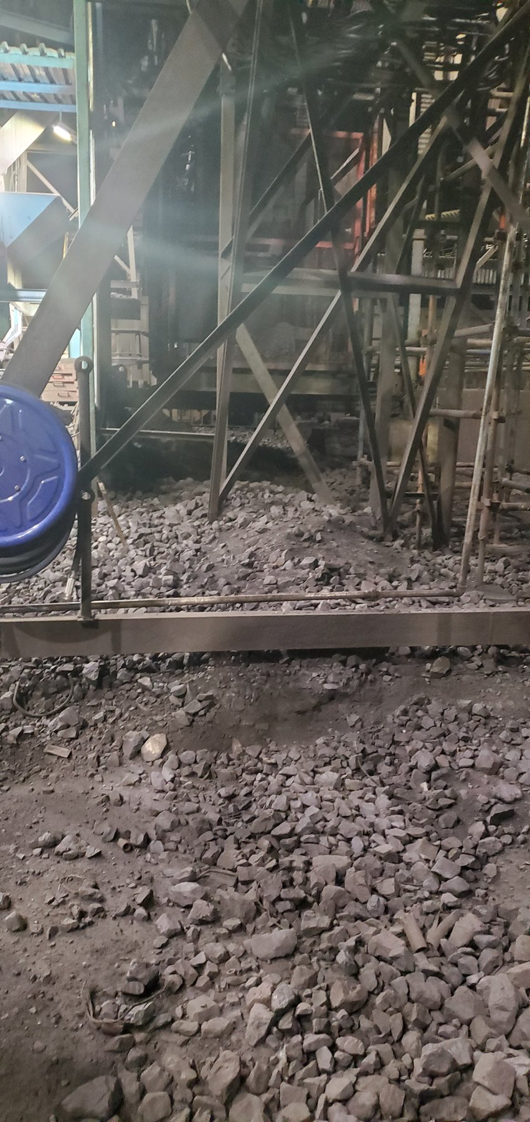  LoadoutStationL1-REF-012 — accumulation at a separate nearby location supporting spatial persistence.
OBSERVATION | Widespread accumulation, previous/intermittent belt contact evidence, concrete deterioration and multi-location steel deterioration are directly supported.
ENGINEERING ASSESSMENT | The captured running belt is clear of the worn supports, so continuous current contact is not proven. Mistracking is a probable historical mechanism for contact, while remaining structural capacity cannot be determined from photographs.
RECOMMENDED NEXT ACTION | Continue/verify tracking control; commission formal structural assessment and repair/replacement definition for the affected concrete and steel; reduce recurring product/moisture accumulation around the structure.
PART VIII — EVENT-DRIVEN AND OPERATIONAL SPILLAGE

20 Trips, Restart and Manual Product Removal
Not all spillage is chronic. A trip, blockage or restart intervention can leave a loaded belt that must be partially cleared before safe restart. Where product is deliberately removed during that intervention and placed beside the conveyor or at another temporary safe location, the resulting deposit is an event-driven condition and should be distinguished from recurring mechanically generated spillage.
The required control is primarily procedural: confirm the applicable trip/restart unloading instruction, authorised responsibility, temporary placement or containment arrangement, and the method and timing for recovery or reintroduction of the removed product. Where the applicable South32 instruction has not yet been verified, the report leaves the detailed procedure to that controlled site process rather than inventing one.

21 Housekeeping — Necessary but Not the Primary Solution
Housekeeping remains necessary to maintain safe access, recover material and restore operating condition after accumulation or unavoidable events. It is, however, a consequence-control activity rather than a substitute for correcting a recurring source mechanism. Records of repeated accumulation can also provide useful feedback on whether engineering improvements are reducing the recurrence.
CONTROL PRINCIPLE | Housekeeping controls the consequence. Source control should reduce the recurrence.
Housekeeping and recovery responsibilities, appropriate inspection or clearing frequency and repeat-accumulation trending should therefore support the engineering programme, particularly in restricted-access areas such as W10. Where a recurring source can be identified and corrected, source control remains the preferred route to reducing the frequency of cleanup.
PART IX — WHAT THE COMBINED EVIDENCE MEANS

22 Consolidated Engineering Interpretation
Taken together, the evidence does not support the idea of one mine-wide spillage defect. It indicates a connected material- and process-containment problem expressed through several different mechanisms. This allows one common engineering objective to be applied across the system while the physical correction remains specific to the mechanism and local geometry.
Level | Mechanism / condition | Engineering meaning
Systemic / recurring | Fines carryback; variable cleaner condition/effectiveness; incomplete containment of removed fines at some discharges. | Primary opportunity is source control at relevant discharge/cleaner locations rather than repeated downstream cleanup.
Local / geometry-specific | W10 coarse transit loss; Sample 2/3 limited carrying margin; Sample 3 mistracking; U4 mistracking; L3 offset. | Requires local feed, tracking, geometry and containment verification rather than one universal hardware solution.
Water / structural | Confirmed Screens water escape; CV01/CV04 wet conditions; Screens and L1 structural deterioration. | Water containment and structural integrity require dedicated inspection/assessment and should not be treated as housekeeping only.
Operational | Trip/restart unloading and recurring housekeeping. | Procedure and recovery controls are required, but should support rather than replace source correction.
The strongest recurring system themes are fines/carryback, variable cleaner condition or effectiveness, and incomplete containment of cleaner-removed material at some discharges. Other findings are more local: coarse-product loss at W10, limited carrying margin and feed concerns at the Sample Conveyors, supported mistracking at Sample Conveyor 3 and U4, and an alignment concern at L3. The Screens and L1 also require dedicated water or structural assessment, while trip/restart handling and housekeeping remain supporting operational controls rather than one common mechanical cause.
The most important systems insight remains that the visible deposit location may be the consequence location rather than the initiating cause location. For that reason, the recommended programme is organised around the material-control function and the mechanism supported by the evidence, rather than simply around the locations of the largest photographed deposits.
PART X — THE ENGINEERING CONTROL PHILOSOPHY

23 Engineering Control Philosophy — Keep the Combined Product Inside the Process
CORE PRINCIPLE | Keep the combined product — fines and coarse/lump ore — within the intended material-handling path throughout transit, and keep process water within the screening and processing systems where it is intended to remain, using controls appropriate to the specific failure mechanism and local geometry.

23.1 Fines / Carryback
- Remove residual fines effectively at appropriate discharge locations.
- Maintain cleaner contact and the required adjustment/wear-compensation function through service.
- Keep cleaner-removed fines within the intended chute/process stream.
- Prove the functional philosophy at CV09, then assess wider applicability by function and local geometry.

23.2 Coarse / Lump Product
- Verify feed quantity, representative product size and trajectory relative to usable carrying width.
- Maintain suitable belt centring/tracking and carrying margin.
- Use location-specific secondary side containment only where a residual duty remains after primary contributors are addressed.
- Keep secondary barriers/rails outside the verified normal belt operating envelope.

23.3 Transfer Points and Process Water
- Keep transfer material within the chute/process path and correct confirmed source contributors before adding secondary controls.
- Retain process water within the screening/washing process and correct the actual verified escape mechanism after safe shutdown investigation.

23.4 Operational Events
- Use controlled temporary placement/containment during unavoidable trip/restart clearing.
- Define authorised responsibility, recovery/reintroduction route and timing.
- Keep event-driven product handling distinguishable from recurring source-generated spillage.
A practical control sequence is to identify the likely loss mechanism, verify the relevant geometry or operating condition, correct the source or primary contributor where practicable, provide the required primary containment, add secondary containment where a residual duty remains, and then confirm the result under representative operation.
PART XI — RECOMMENDED ACTION PROGRAMME

24 Programme Structure and Implementation Principle
The recommended programme follows the control hierarchy established in Part X. Its purpose is to convert the audit findings into practical work that can be measured, implemented and then checked in operation. The priorities are to prove or restore the main fines-control functions, address the supported local material-loss and alignment concerns, resolve the process-water and structural issues, extend successful controls only where they suit the local geometry, and strengthen operational and housekeeping arrangements as supporting controls. Conceptual arrangements remain subject to site verification and the appropriate South32, responsible-engineer or OEM review.

24.1 Priority 1A — Prove the Cleaner / Fines-Containment Function at CV09
Engineering objective: demonstrate a practical cleaner-and-containment arrangement that materially reduces downstream wet-fines carryback and keeps material removed from the belt within the intended process/fines-discharge stream.

Required action sequence
- Establish the as-found baseline: record cleaner arrangement/contact condition, local chute/enclosure geometry, intended removed-fines route, maintenance/guarding access and representative pre-trial fallout/carryback condition.
- Complete detailed design development from verified site geometry, including cleaner-to-belt contact through the agreed wear condition, travel limitation, containment geometry, removed-fines route, cleaning stages where justified and safe inspection/replacement access.
- Install and commission only after geometry, cleaner selection, safety and maintenance requirements are verified and accepted by the responsible authorities.
- Monitor representative operation for an agreed period and compare the post-modification condition with the as-found baseline before wider rollout is considered.

Functional acceptance / close-out criteria
- Downstream carryback materially reduced relative to the pre-trial condition.
- Cleaner-removed wet fines retained within the intended process stream.
- Stable cleaner contact maintained through the agreed operating/wear condition without unacceptable belt damage or abnormal cleaner wear.
- Inspection, adjustment and replacement remain practical; no unacceptable guarding, trapping or access conflict is introduced.
- Monitoring record is sufficient for a defensible wider-applicability decision.
Evidence traceability: CV09-REF-002, CV09-REF-003, video CV09-REF-006; CV09-REF-008 supplementary. Final cleaner type, OEM wear limits, detailed chute modification and trial duration remain South32 / responsible-engineer / OEM decisions as applicable.

24.2 Priority 1B — Restore and Verify CV06 Cleaner Function
Engineering objective: restore the directly compromised CV06 cleaner function and verify a complete, mechanically supported and operating cleaner arrangement before considering broader redesign.
- Inspect the full cleaner assembly/support arrangement and establish the condition of the housing, displaced bush/insert, cross-shaft, blades and adjustment system.
- Restore or replace defective/missing components through the applicable maintenance/OEM process; where records permit, investigate why the support bush displaced and why blades were absent.
- Verify blade coverage/contact, support integrity and adjustment after restoration, then observe the cleaner during representative operation.
Close-out requires the support defect to be corrected, required blade elements present across the intended working width, cleaner support/adjustment function verified, and any residual carryback/containment issue recorded for separate mechanism-based follow-up. Evidence: CV06-REF-004 and CV06-REF-005.

25 Priority 2 — Correct or Verify Local Material-Loss / Alignment Mechanisms
Priority 2 addresses the local material-loss and alignment conditions that are either confirmed or sufficiently supported to justify targeted measurement and corrective work. The evidence boundary is retained at locations such as L3, where the alignment concern is supported but significant solid-product loss has not been established as a direct consequence.

25.1 U4 Tripper Car — Tracking / Alignment Correction
Objective: restore and maintain a suitably centred belt path through the full tripper operating range so the verified one-sided product-loss condition is removed or materially reduced.
- Establish fixed repeatable survey/reference points and quantify relevant tail-pulley, support and belt-path geometry in the as-found condition.
- Inspect adjustment/support condition, remove trapped material that could distort assessment, and correct the confirmed geometry/tracking contributor as required.
- Verify belt tracking under representative operation through the full tripper travel range and retain the as-left geometry/reference baseline.
Close-out: stable/centred tracking and adequate carrying margin demonstrated through full travel; one-sided product loss materially reduced/removed; U4 cleaner requirements assessed separately. Evidence: UGU4-REF-009, UGU4-REF-007, video UGU4-REF-010, cleaner context UGU4-REF-011/-012.

25.2 Sample Conveyor 3 — Feed, Tracking and Secondary Containment
Objective: reduce coarse/mixed-product loss by addressing feed and tracking contributors before finalising secondary side containment.
- Measure usable carrying width; document representative product size/feed; identify feed-control/metering; observe feed trajectory; quantify lateral offset/mistracking; inspect head/tail alignment, tensioning and relevant supports/idlers.
- Correct/control verified feed or tracking contributors, then reassess the residual containment duty.
- If secondary containment remains necessary, develop it from the verified operating envelope with suitable belt clearance, clean-out access and protection against trapping/abnormal belt contact.
Close-out: width/feed condition documented; offset quantified; primary contributors controlled; coarse/mixed loss materially reduced; any remaining containment remains clear/maintainable and does not become a normal belt-contact surface. Evidence: LoadoutStationSample3-REF-013, -005/-006, -002 and -012.

25.3 Sample Conveyor 2 — Feed / Loading Verification Before Secondary Containment
Objective: establish the relationship between incoming product, representative product size and usable belt carrying width before attributing the condition to mistracking or committing to final side-containment geometry.
- Measure usable belt width; document representative product/feed condition and trajectory; identify feed-control/metering; verify head/tail alignment and live tracking without presuming significant mistracking; establish normal belt-edge clearance.
- Determine whether feed control materially improves containment, then develop secondary support/skirt/rail only if a residual duty remains.
Close-out: feed/belt geometry documented; feed controlled to a containable condition; significant mistracking ruled out or corrected if found; visible loss materially reduced; any secondary containment maintains clearance/access. Evidence: LoadoutStationSample2-REF-004, -006/-007, supporting -001/-003.

25.4 W10 — Source-Control Review and Side-Containment Feasibility
Objective: reduce mixed/coarse-product migration into the restricted W10 access route without creating a barrier that routinely contacts the belt or introduces new trapping, wear or maintenance hazards.
- Establish the normal tracking envelope and record belt/trough/support/side-clearance geometry.
- Investigate likely initiating contributors and source-control opportunities; distinguish return-side fines from carrying-side coarse/mixed loss where the evidence allows.
- Define clean-out/access requirements and, only if still justified, develop a secondary barrier/rail outside the verified normal belt operating envelope.
Close-out: geometry/tracking envelope verified; initiating contributors investigated/corrected where practicable; any barrier remains outside normal belt contact; access/trapping/wear/maintenance assessed; tunnel accumulation materially reduced. Evidence: W10-REF-002, W10-REF-010/-011, supporting W10-REF-006/-009.

25.5 L3 — Quantitative Alignment / Tracking Verification
Objective: quantify and correct the supported L3 tail-end alignment/offset condition where required, while preserving that significant solid/lump-product loss is not established as a direct consequence.
- Establish fixed references; measure pulley/belt/support-frame geometry; inspect adjustment/idler/tensioning condition; remove local material that could influence assessment; observe representative live tracking.
- Correct any verified alignment/tracking defect and retain as-left geometry/operating belt position. Observe whether the corrected condition changes local fines/material accumulation without retrospectively promoting an unproven solid-product causal claim.
Close-out: geometry quantitatively established; confirmed defect corrected/dispositioned; live tracking recorded; as-left references retained; evidence boundary maintained. Evidence: LoadoutStationL3-REF-001, -007, supporting -008.

26 Priority 3 — Water Containment and Structural Actions
Priority 3 treats process-water containment and structural integrity as related but separate workstreams so that each can be investigated and addressed according to its own evidence and engineering requirements.

26.1 Screens — Identify the Water-Escape Mechanism Before Modification
Objective: retain process water and entrained wet fines within the screening/chute process by correcting the verified escape mechanism rather than designing from an assumed cause.
- Complete a safe shutdown inspection and correlate observations with the existing dynamic water-escape videos.
- Identify actual escape path(s) and assess relevant seals, chute interfaces, screen movement/clearance, enclosure geometry and maintenance condition; record design-input geometry.
- Develop/implement the containment modification only after the mechanism is established, then verify representative operation.
Close-out: actual mechanism identified; modification addresses it; process water/wet fines retained to the accepted operating standard; no unacceptable maintenance/access conflict. Evidence: Screen-REF-016/-017 supported by the Screens photo set.

26.2 Screens — Structural Support Assessment
Objective: establish the condition and remaining capacity of cut/notched/corroded support members and define the required repair/replacement scope independently of unverified assumptions about why the damage occurred.
- Appoint a competent structural authority; record member dimensions, cut/notch geometry, section loss, connection condition and other required assessment inputs.
- Determine remaining capacity and repair/replacement scope; formally calculate/approve any revised support geometry required for future equipment or maintenance clearance.
Close-out: competent structural assessment complete; capacity/status and repair requirement defined; intervention completed or formally controlled/scheduled; revised geometry checked/approved. Evidence: Screen-REF-006/-010, supporting -004/-008.

26.3 L1 — Structural Condition and Belt-Clearance Verification
Objective: define/correct the documented L1 structural deterioration, reduce conditions that may accelerate further deterioration, and verify suitable representative belt clearance from the affected support geometry.
- Complete competent assessment of affected concrete, reinforcement, steel members and connections; record dimensions/section loss and wear-slot/contact geometry.
- Verify representative belt tracking/clearance; do not infer continuous present contact from historic/intermittent wear marks unless direct verification establishes it.
- Implement the required structural repair/replacement and reduce recurring fines/moisture accumulation around repaired interfaces.
Close-out: structural condition/capacity assessed; repair scope implemented/controlled; representative clearance confirmed; evidence distinction retained; recurring fines/moisture materially reduced or controlled. Evidence: LoadoutStationL1-REF-007, -003/-005, -008, -013; -017 supporting.

27 Priority 4 — Extend Proven Controls Where Applicable
Once the CV09 pilot and the targeted local corrections have demonstrated a satisfactory result, the same functional requirements can be assessed at other relevant discharges and vulnerable transport sections. The intention is to standardise the required material-control function rather than one identical item of hardware. Each location should first be reviewed for its actual mechanism, cleaner and maintenance condition, belt and material state, chute/discharge geometry, tracking or loading condition, installation space, route for removed material, guarding and maintenance access.
A successful result at one location should therefore lead to wider assessment of the same functional philosophy, not automatic replication of the same hardware. If CV09 performs well, that would justify reviewing other suitable conveyors for the same cleaner-and-containment objective while still allowing U4 and other geometry-specific locations to receive a different physical arrangement.

28 Priority 5 — Operational and Housekeeping Governance
Operational and housekeeping controls remain necessary for event-driven deposits, safe access, recovery and performance feedback. Where a recurring material-loss mechanism can be corrected through engineering or maintenance action, those operational controls should support the source correction rather than replace it.

28.1 Trip / Restart Product Handling
Confirm the current written trip/restart unloading practice; define authorised responsibility for unloading, temporary placement/containment and recovery; define how/when removed product returns to the process; and ensure event-driven clearing remains distinguishable from recurring mechanically generated spillage.
Close-out: documented/approved procedure, explicit responsibilities, controlled temporary placement, defined recovery/reintroduction route and identifiable separation of event-driven versus chronic deposits.

28.2 Housekeeping / Recovery
Confirm housekeeping/recovery responsibilities and appropriate inspection/clearing frequency. Where repeat accumulation is significant, retain sufficient records to support trend assessment and use recurring accumulation as feedback on source-control performance. Maintain safe access/escape routes, particularly in restricted areas such as W10.
Governing principle: Housekeeping controls the consequence. Source control should reduce the recurrence.

28.3 Programme Close-Out Rule
Each material action should retain the evidence chain: as-found evidence → verification/measurement → corrective design or control → implementation → representative operating proof → as-left record → monitoring/closure. Maintenance sign-off, installation completion or a cleaned area is an intermediate milestone unless the intended functional outcome is also demonstrated.

28.4 Consolidated Priority Action Register
Priority | Action | Type | Verification / design requirement | Primary evidence / case
1A | CV09 cleaner + containment pilot | Design development / pilot | As-found geometry; cleaner/contact/wear function; containment/fines route; representative monitoring | CV09
1B | CV06 cleaner restoration | Maintenance / operating verification | Restore support/blades; verify contact/coverage/support; operating check | CV06
2 | U4 tracking/alignment correction | Corrective maintenance + verification | Quantify geometry; correct; prove full tripper travel; retain as-left baseline | U4
2 | Sample Conveyor 3 feed/tracking/containment | Process / mechanical design | Measure width/feed/offset; correct primary contributors; residual containment only | Sample 3
2 | Sample Conveyor 2 feed/loading verification | Process verification | Measure width/feed; live tracking check without presumption; residual containment only | Sample 2
2 | W10 source review / barrier feasibility | Engineering verification / concept | Tracking envelope; geometry; source contributors; barrier clearance/access if justified | W10
2 | L3 alignment/tracking verification | Mechanical verification | Quantify tail-end geometry; live tracking; correct/disposition; retain causal qualification | L3
3 | Screens water escape investigation | Shutdown inspection / design input | Identify actual escape mechanism before detailed modification; operating proof | Screens
3 | Screens structural assessment | Structural | Member/cut/notch/section-loss assessment; capacity and repair disposition | Screens
3 | L1 structural + clearance verification | Structural / mechanical | Capacity/repair assessment; representative belt clearance; reduce recurring fines/moisture | L1
5 | Trip/restart + housekeeping governance | Operational | Confirm procedure, responsibilities, controlled laydown/recovery and repeat-accumulation trending | System-wide
PART XII — CONCLUSION

29 Conclusion
The Combined Product Spillage Audit indicates that spillage across the inspected Wessels Mine material-handling route is not the result of one isolated defect. Taken together, the findings show a broader material- and process-containment problem expressed through several different mechanisms at different locations.
Recurring fines/carryback is the strongest system-wide pattern. CV06 provides a clear example of a compromised cleaner condition, while CV09 shows that removing material from the belt is only part of the control function: if the removed fines are not retained within the intended discharge/process path, they can still become plant-area spillage. Effective fines control therefore requires both reliable belt cleaning and a controlled route for the removed material back into the process.
Coarse or mixed-product loss at W10 and the Sample Conveyors requires a different response focused on the usable carrying area of the belt. Feed condition, local geometry, belt tracking and secondary containment all need to be considered according to the evidence at each location. Sample Conveyor 2 remains primarily a feed/loading/containment concern without proven significant mistracking; Sample Conveyor 3 additionally shows supported lateral offset/mistracking whose magnitude still needs to be measured. U4 provides the clearest local relationship between tracking and one-sided product loss, while L3 remains an alignment concern without an equivalent proven significant solid-product causal chain.
At the Screens, active process-water escape is directly verified, while the precise equipment-level escape mechanism still needs to be established during a controlled inspection. Severe corrosion/deterioration and cut/notched supports are also visible, but the remaining structural capacity and the historical reason for those alterations require competent structural assessment. L1 similarly combines extensive accumulation, evidence of previous or intermittent belt contact, concrete deterioration and steel deterioration; these findings should be addressed together without assuming that one condition proves the cause of all the others.
The audit also distinguishes recurring source-generated spillage from material that may be removed deliberately during a trip, blockage or restart intervention. Such material still needs controlled placement and recovery, but its presence beside a conveyor should not automatically be interpreted as evidence of a chronic mechanical failure at that exact location.
Across all of these mechanisms, the common engineering objective is to keep the combined product — fines and coarse/lump ore — within the intended material-handling path throughout transit and to keep process water within the screening and processing systems where it is intended to remain. The physical solution should match the mechanism and local geometry. For that reason, the report does not recommend one identical cleaner, skirt, barrier or mechanical modification throughout the system; what can be standardised is the required engineering function and the way its performance is checked.
The recommended programme therefore combines practical corrective work with the measurement and operating checks needed to confirm that each action has achieved its intended purpose. As-found evidence should be retained, the relevant geometry or operating condition should be verified, the correction should be implemented, and the result should then be checked under representative service and recorded for future reference. Housekeeping remains essential for access, recovery and safe operation, but recurring cleanup on its own does not show that the underlying source has been corrected.
The ultimate objective is not simply a cleaner plant floor. It is a material-handling system in which the product and process water remain controlled through the intended process, local problems are addressed according to the mechanism and geometry established at each location, and unavoidable losses or operating interventions are contained, recoverable and deliberately managed.
FINAL TAKEAWAY | The goal is not simply a cleaner plant floor. It is a material-handling system in which the product and process water remain controlled through the intended process and where unavoidable losses or interventions are contained, recoverable and deliberately managed.

30 Technical Review and Report Issue Sign-off
This V0.5 document is the first terminology-refined revision of the language-harmonised V0.4 draft and remains NOT FOR ISSUE. The report architecture, engineering conclusions, evidence-to-action framework and V0.2-derived narrative voice remain unchanged. Detailed inspector wording/content review, outstanding site measurements and structural assessments, engineer review of the conceptual drawings, final priority/rating closure where applicable, publication styling, automatic registers/cross-references and formal authorization remain subsequent controlled tasks.
Role | Name | Status
Prepared by | Inspection & Specification Services cc. | V0.5 terminology-refined draft prepared
Technical review | [TO BE COMPLETED] | Pending engineer / technical review
Client review / action alignment | [TO BE COMPLETED] | Pending
Approved for issue | [TO BE COMPLETED] | Pending

APPENDICES — TECHNICAL EVIDENCE BACKBONE

Appendix A — Full Asset-by-Asset Audit Matrix
Appendix A provides the report-facing 23-group asset audit matrix. It summarises each controlled inspection group, the strongest supported condition/mechanism, representative evidence references and the action direction. The full 197-row EVIDENCE_STORY_MATRIX_V0.1.csv remains the detailed item-level evidence source.
Area | Asset / group | Verified condition / mechanism | Key evidence | Action direction
Underground - Central Block | Underground Crusher | Mixed coarse/lump and fines accumulation; local standing water visible, source unresolved. | UGCrusher-REF-001/-002 | Investigate local material/water contributors; maintain source-control/carryback review.
Underground - Central Block | UC05-UC01 continuous system | Distributed dry fines with mixed coarse fragments; severe local mounds and clear comparator sections. | UGUC05_04_03_02_01-REF-005/-006/-007/-015 | Treat as systemic recurrence/carryback story; target discharge/cleaner source control and trending.
Underground - Secondary Plant | U3 Conveyor | Local conveyor-adjacent fines/mixed accumulation; roadway coarse rock not automatically conveyor spillage. | UGU3-REF-004/-007 | Maintain origin qualification; local inspection/source control as required.
Underground - Secondary Plant | U4 Tripper Car | Verified severe local spillage, lateral mistracking and one-sided product loss; alignment magnitude unmeasured. | UGU4-REF-009/-007; video -010 | Quantify/correct geometry and prove full-travel tracking; assess cleaner separately.
Underground - Silos / Feeders | U5A Conveyor | Extensive/widespread dry fines; return-side geometry strongly consistent with carryback. | UG5A-REF-002/-004/-006 | Prioritise cleaner/discharge source-control applicability review.
Underground - Silos / Feeders | U5B Conveyor | Trace-to-localised dry fines overall with some sizeable local deposits. | UG5B-REF-001/-003/-006 | Maintain localised classification; inspect source/cleaner only as evidence warrants.
Surface - Screening / Transfer | W10 | Substantial coarse/mixed product in restricted tunnel; exact initiating cause unresolved. | W10-REF-002/-010; supporting -006/-009 | Verify tracking/geometry/source contributors; secondary barrier feasibility only if residual duty remains.
Surface - Screening / Transfer | CV01 | Wet-fines/slurry and pooled water; severe visible roller surface damage; seized state not dynamically proven. | CV01-REF-001/-003 | Correct maintenance condition; investigate water/material source without overclaim.
Surface - Screening / Transfer | CV02 | Dry fines plus mixed/lump accumulation around transfer/return-side structure. | CV02-REF-001/-003 | Supporting fines/carryback/source-control review.
Surface - Screening / Transfer | CV03 | No significant spillage in inspected condition; clean comparator. | CV03-REF-002 | Retain as time-specific comparator; no escalation.
Surface - Screening / Transfer | CV04 | Saturated wet-fines/slurry and multiple piles; extensive/widespread. | CV04-REF-002/-005 | Investigate water/material source and containment; source not inferred from stills.
Surface - Screening / Transfer | CV06 | Displaced cleaner support bush/insert; scraper blades absent from working width. | CV06-REF-004/-005 | Restore and verify cleaner function; investigate history where records permit.
Surface - Screening / Transfer | CV09 | Wet-fines/slurry, contaminated cleaner region and active fallout; cleaner/containment interface case. | CV09-REF-002/-003; video -006 | Develop/monitor cleaner + process-containment pilot from verified geometry.
Surface - Screening / Transfer | CV14 | Trace/localised dry fines/carryback deposits. | CV14-REF-002 | Supporting low-severity recurrence; no escalation.
Surface - Screening / Transfer | CV15 | Extensive distributed fines/carryback around chute E-3181; stills mainly dry/dried. | CV15-REF-003/-004/-006 | Assess cleaner/discharge functionality; retain wet-condition qualification.
Surface - Screening / Transfer | Screens / screen chutes | Active process-water escape verified; severe corrosion and cut/notched supports verified; exact mechanism/capacity unresolved. | Screen-REF-016/-017; photos -004/-006/-010 | Shutdown water-mechanism investigation plus competent structural assessment.
Surface - Loading Station | L1 Conveyor | Extensive spillage; severe concrete/steel deterioration; previous/intermittent belt-contact evidence. | LoadoutStationL1-REF-007/-005/-008/-013 | Competent structural assessment/repair plus representative belt-clearance verification.
Surface - Loading Station | L2 Conveyor | No significant spillage in inspected condition; photo/video comparator. | LoadoutStationL2-REF-004.jpg / REF-005 media | Retain time-specific clean comparator; no chronic claim.
Surface - Loading Station | L3 Conveyor | Tail-end offset supported but unmeasured; fines visible; significant solid-product causal chain not established. | LoadoutStationL3-REF-001/-007 | Quantify alignment/live tracking; correct/disposition without overclaiming product loss.
Surface - Loading Station | L4 Conveyor | Localised dry fines and coarse/lump accumulation; operating stills generally contained. | LoadoutStationL4-REF-003/-004 | Local source/containment review as required; no active-fall claim.
Surface - Loading Station | Sample Conveyor 1 | Extensive/widespread mixed fines/coarse accumulation; adhered/dried deposits indicate sticky/moist history. | LoadoutStationSample1-REF-011/-008/-005 | Supporting system consequence/source-control review; active wetness not proven.
Surface - Loading Station | Sample Conveyor 2 | Coarse/lump product occupies substantial narrow belt width; containment loss; significant mistracking not established. | LoadoutStationSample2-REF-004/-006/-007 | Verify feed/product/usable width and live tracking before secondary containment.
Surface - Loading Station | Sample Conveyor 3 | Substantial solid/lump spillage, narrow carrying margin and visually supported mistracking; magnitude unmeasured. | LoadoutStationSample3-REF-013/-005/-002/-012 | Verify feed/usable width; quantify/correct tracking; residual secondary containment if required.

Appendix B — Detailed Photographic Evidence Register
Appendix B provides the controlled photographic register by asset group. All 189 photographs remain retained in the repository and all 197 media items are inspector-reviewed/accepted in the evidence/story matrix. The grouped register below is for report traceability; the CSV remains the authoritative per-item classification record.
Asset / group | Photos | Canonical range / naming | Principal body candidates | Control note
Underground Crusher | 5 | UGCrusher-REF-001..005 | UGCrusher-REF-001/-002 | All retained; body selection uses smallest sufficient E/S set. See EVIDENCE_STORY_MATRIX_V0.1.csv for per-item E/S/A classification and qualification.
UC05-UC01 continuous system | 16 | UGUC05_04_03_02_01-REF-001..016 | UGUC05_04_03_02_01-REF-005/-006/-007/-015 | All retained; body selection uses smallest sufficient E/S set. See EVIDENCE_STORY_MATRIX_V0.1.csv for per-item E/S/A classification and qualification.
U3 Conveyor | 8 | UGU3-REF-001..008 | UGU3-REF-004/-007 | All retained; body selection uses smallest sufficient E/S set. See EVIDENCE_STORY_MATRIX_V0.1.csv for per-item E/S/A classification and qualification.
U4 Tripper Car | 11 | UGU4 photos: REF-001..009, -011..012 | UGU4-REF-009/-007; video -010 | All retained; body selection uses smallest sufficient E/S set. See EVIDENCE_STORY_MATRIX_V0.1.csv for per-item E/S/A classification and qualification.
U5A Conveyor | 9 | UG5A-REF-001..009 | UG5A-REF-002/-004/-006 | All retained; body selection uses smallest sufficient E/S set. See EVIDENCE_STORY_MATRIX_V0.1.csv for per-item E/S/A classification and qualification.
U5B Conveyor | 6 | UG5B-REF-001..006 | UG5B-REF-001/-003/-006 | All retained; body selection uses smallest sufficient E/S set. See EVIDENCE_STORY_MATRIX_V0.1.csv for per-item E/S/A classification and qualification.
W10 | 12 | W10-REF-001..012 | W10-REF-002/-010; supporting -006/-009 | All retained; body selection uses smallest sufficient E/S set. See EVIDENCE_STORY_MATRIX_V0.1.csv for per-item E/S/A classification and qualification.
CV01 | 4 | CV01-REF-001..004 | CV01-REF-001/-003 | All retained; body selection uses smallest sufficient E/S set. See EVIDENCE_STORY_MATRIX_V0.1.csv for per-item E/S/A classification and qualification.
CV02 | 4 | CV02-REF-001..004 | CV02-REF-001/-003 | All retained; body selection uses smallest sufficient E/S set. See EVIDENCE_STORY_MATRIX_V0.1.csv for per-item E/S/A classification and qualification.
CV03 | 3 | CV03-REF-001..003 | CV03-REF-002 | All retained; body selection uses smallest sufficient E/S set. See EVIDENCE_STORY_MATRIX_V0.1.csv for per-item E/S/A classification and qualification.
CV04 | 5 | CV04-REF-001..005 | CV04-REF-002/-005 | All retained; body selection uses smallest sufficient E/S set. See EVIDENCE_STORY_MATRIX_V0.1.csv for per-item E/S/A classification and qualification.
CV06 | 5 | CV06-REF-001..005 | CV06-REF-004/-005 | All retained; body selection uses smallest sufficient E/S set. See EVIDENCE_STORY_MATRIX_V0.1.csv for per-item E/S/A classification and qualification.
CV09 | 5 | CV09-REF-001..005 | CV09-REF-002/-003; video -006 | All retained; body selection uses smallest sufficient E/S set. See EVIDENCE_STORY_MATRIX_V0.1.csv for per-item E/S/A classification and qualification.
CV14 | 2 | CV14-REF-001..002 | CV14-REF-002 | All retained; body selection uses smallest sufficient E/S set. See EVIDENCE_STORY_MATRIX_V0.1.csv for per-item E/S/A classification and qualification.
CV15 | 8 | CV15-REF-001..008 | CV15-REF-003/-004/-006 | All retained; body selection uses smallest sufficient E/S set. See EVIDENCE_STORY_MATRIX_V0.1.csv for per-item E/S/A classification and qualification.
Screens / screen chutes | 14 | Screen-REF-001..014 | Screen-REF-016/-017; photos -004/-006/-010 | All retained; body selection uses smallest sufficient E/S set. See EVIDENCE_STORY_MATRIX_V0.1.csv for per-item E/S/A classification and qualification.
L1 Conveyor | 18 | LoadoutStationL1-REF-001..018 | LoadoutStationL1-REF-007/-005/-008/-013 | All retained; body selection uses smallest sufficient E/S set. See EVIDENCE_STORY_MATRIX_V0.1.csv for per-item E/S/A classification and qualification.
L2 Conveyor | 6 | LoadoutStationL2-REF-001..006.jpg | LoadoutStationL2-REF-004.jpg / REF-005 media | All retained; body selection uses smallest sufficient E/S set. See EVIDENCE_STORY_MATRIX_V0.1.csv for per-item E/S/A classification and qualification.
L3 Conveyor | 8 | LoadoutStationL3-REF-001..008 | LoadoutStationL3-REF-001/-007 | All retained; body selection uses smallest sufficient E/S set. See EVIDENCE_STORY_MATRIX_V0.1.csv for per-item E/S/A classification and qualification.
L4 Conveyor | 8 | LoadoutStationL4-REF-001..008 | LoadoutStationL4-REF-003/-004 | All retained; body selection uses smallest sufficient E/S set. See EVIDENCE_STORY_MATRIX_V0.1.csv for per-item E/S/A classification and qualification.
Sample Conveyor 1 | 11 | LoadoutStationSample1-REF-001..011 | LoadoutStationSample1-REF-011/-008/-005 | All retained; body selection uses smallest sufficient E/S set. See EVIDENCE_STORY_MATRIX_V0.1.csv for per-item E/S/A classification and qualification.
Sample Conveyor 2 | 8 | LoadoutStationSample2-REF-001..008 | LoadoutStationSample2-REF-004/-006/-007 | All retained; body selection uses smallest sufficient E/S set. See EVIDENCE_STORY_MATRIX_V0.1.csv for per-item E/S/A classification and qualification.
Sample Conveyor 3 | 13 | LoadoutStationSample3-REF-001..013 | LoadoutStationSample3-REF-013/-005/-002/-012 | All retained; body selection uses smallest sufficient E/S set. See EVIDENCE_STORY_MATRIX_V0.1.csv for per-item E/S/A classification and qualification.

Appendix C — Video Evidence Register
Appendix C lists the 8 controlled videos individually. Video is used where dynamic operating state materially strengthens the evidence; extracted static frames remain derivatives of the original video and retain the original canonical evidence ID.
Asset | Canonical ID | Repository filename | Evidence role | Qualification
CV09 | CV09-REF-006 | Cv09-Ref-006.mp4 | Active wet-material fallout during operation; principal dynamic proof. | Does not define final cleaner/chute geometry.
CV09 | CV09-REF-007 | Cv09-Ref-007.mp4 | Supplementary operating context for wet-fines / cleaner region. | Supporting dynamic evidence; use only where it adds unique context.
CV09 | CV09-REF-008 | Cv09-Ref-008.mp4 | Dynamic cleaner/chute contamination and containment-boundary context. | Supports pilot context; not final design geometry.
Screens | Screen-REF-015 | Screen-REF-015.mp4 | Supplementary screen operating / water context. | Supporting only unless unique mechanism detail is required.
Screens | Screen-REF-016 | Screen-REF-016.mp4 | Direct active process-water escape / spray. | Proves active escape, not exact equipment-level cause.
Screens | Screen-REF-017 | Screen-REF-017.mp4 | Wider substantial water spray/runoff / repeated wetting. | Proves active escape/extent, not structural causation.
L2 | LoadoutStationL2-REF-005 (video) | LoadoutStationL2-REF-005.mp4 | Dynamic clean-condition / no-significant-spillage comparator for inspected state. | Duplicate numeric ID exists as JPG; always state media type/exact filename.
U4 | UGU4-REF-010 | UGU4-REF-010.MP4 | Dynamic tail-pulley/belt alignment/tracking context. | Supports inspector-recorded concern; not quantitative geometry.

Appendix D — Measurements / Verification Required
ID | Case / verification | Class | Gate | Required evidence | Decision / close-out dependency
VER-001 | CV09 as-found geometry / pilot design inputs | M/D/O | G1 | Survey cleaner/chute geometry/access/fines route + pre-trial baseline | Before final cleaner/chute design
VER-002 | CV09 pilot functional performance | O/P | G3/G4 | Representative monitoring + before/after evidence + maintenance record | Before wider rollout
VER-003 | CV06 cleaner restoration | M/O | G2/G3 | Maintenance repair record + post-repair configuration + operating proof | Before cleaner close-out
VER-004 | U4 alignment/tracking/full travel | M/O | G1/G2/G3 | As-found/as-left survey + full-travel operating record + loss comparison | Before final tracking close-out
VER-005 | Sample 3 feed/width/tracking | M/O/D | G1/G2/G3 | Width/feed/trajectory + offset/alignment + post-correction proof | Before final side containment
VER-006 | Sample 2 feed/loading verification | M/O/D | G1/G2/G3 | Width/feed/trajectory + live tracking check + post-adjustment observation | Before causal/containment finalisation
VER-007 | W10 tracking envelope/source/barrier feasibility | M/O/D | G1/G2/G3 | Tracking/geometry + source review + barrier feasibility/clearance if needed | Before barrier design/close-out
VER-008 | L3 quantitative alignment/live tracking | M/O | G2/G3 | As-found/as-left geometry + live tracking + local post-correction condition | Before alignment close-out
VER-009 | Screens water-escape mechanism | O/D/M | G1/G2/G3 | Shutdown mechanism record + design geometry + post-mod operating proof | Before detailed modification/close-out
VER-010 | Screens structural condition/capacity | S/M | G1/G2/G3 | Competent assessment: members, cuts/notches, section loss, connections, capacity/repair | Before structural acceptance
VER-011 | L1 structural + belt clearance | S/M/O | G1/G2/G3 | Competent structural record + wear/contact geometry + representative tracking/clearance | Before structural/mechanical close-out
VER-012 | Trip/restart governance | C | G2/G3 | Approved procedure + responsibilities + laydown/recovery/reintroduction route | Before operational close-out
VER-013 | Housekeeping / recovery governance | C | G3 | Responsibility/frequency + repeat-accumulation trend records | Ongoing performance feedback
VER-014 | Wider applicability / rollout | A | G4 | Proven pilot/local result + location-specific mechanism/geometry/access review | Before standardisation/rollout

Appendix E — Conceptual Engineering Drawings
Appendix E controls the current conceptual engineering figures. These figures are accepted for the present report compilation as explanatory concepts but remain subject to later engineer review, technical refinement and site-geometry verification. They are not fabrication drawings and are not inspection evidence.
ID | Title | Report use | Current control status
CTD-001 | CV09 Cleaner and Process-Containment Concept | Body Part IV / Appendix E | Working concept accepted for report; engineer review/refinement deferred.
CTD-002 | W10 Side-Containment Barrier Principle | Body Part V / Appendix E | Secondary barrier concept; tracking/clearance/site geometry to be verified.
CTD-003 | Sample Conveyor Containment-Control Hierarchy | Body Part V / Appendix E | Instructional hierarchy; not site-specific final geometry.
CTD-004 | Cause Location vs Deposit Location | Body Part II / Appendix E | Explanatory audit principle; conceptual, not inspection evidence.

CTD-001 — CV09 Cleaner and Process-Containment Concept — CONCEPTUAL ONLY / NOT FOR FABRICATION / DIMENSIONS TO BE VERIFIED WHERE APPLICABLE.

CTD-002 — W10 Side-Containment Barrier Principle — CONCEPTUAL ONLY / NOT FOR FABRICATION / DIMENSIONS TO BE VERIFIED WHERE APPLICABLE.

CTD-003 — Sample Conveyor Containment-Control Hierarchy — CONCEPTUAL ONLY / NOT FOR FABRICATION / DIMENSIONS TO BE VERIFIED WHERE APPLICABLE.

CTD-004 — Cause Location vs Deposit Location — CONCEPTUAL ONLY / NOT FOR FABRICATION / DIMENSIONS TO BE VERIFIED WHERE APPLICABLE.

Appendix F — Source Records
Appendix F identifies the controlled source records used to develop, verify and compile this report. Historical context files remain historical. Current contextual control is maintained through the consolidated V3.9 context, the Phase 6 and Phase 7 addenda, the V3.12 language-style addendum, the V3.13 terminology-refinement addendum, the evidence index/matrix, the Phase 7 controlled drafts and registers, and the V0.2 to V0.5 report lineage.
Source class | Controlled record | Role / status
Inspection questionnaires | Context/Questionaires/Running_Report_Contextual_Spillage_Questionnaire_ResponseV1.docx; V2.docx | Source-recorded inspection/operational context; V2 is later expanded source.
Consolidated engineering context | Context/Running_Report_Contextual_Spillage_NotesV3.9.docx | Primary consolidated engineering context entering Phase 6/7.
Phase 6 historical addendum | Context/Running_Report_Contextual_Spillage_NotesV3.10_Phase6_Addendum.md | Historical Phase 6 assembly context; preserved, not overwritten.
Phase 7 addendum | Context/Running_Report_Contextual_Spillage_NotesV3.11_Phase7_Addendum.md | Phase 7 refinement/control context retained in the current context chain.
Evidence index | Report-Working/evidence_index.md | 23-group repository inventory, visual-review status and first-draft figure candidates.
Visual-review records | Report-Working/evidence_visual_review_batch_A.md through _F.md | Detailed per-item visual evidence strength, limitation and qualification.
Evidence/story matrix | Report-Working/SpillageReport/EVIDENCE_STORY_MATRIX_V0.1.csv / .md | 197-row controlled classification; final 75 E / 44 S / 78 A / 0 X; all accepted.
Narrative architecture / outline | REPORT_NARRATIVE_ARCHITECTURE.md; REPORT_NARRATIVE_OUTLINE_V0.1.md | Accepted report identity, Parts I-XII journey and mechanism-based narrative.
Phase 6 closure | PHASE6_ASSEMBLY_CLOSURE.md | Inspector approval of V0.2 assembly architecture.
Phase 7 content set | PHASE7_FRONT_END_REFINEMENT_DRAFT_V0.1.md; Part IV-VIII drafts; Part IX; Part X; Part XI V0.3; Part XII | Report-ready narrative/action content carried into V0.5; technical substance retained during language and terminology harmonisation.
Verification register | PHASE7_VERIFICATION_SUCCESS_CRITERIA_REGISTER_V0.1.md | Controlled VER-001..VER-014 measurement/inspection/design/close-out requirements.
Concept figure register | PHASE7_CONCEPTUAL_ENGINEERING_FIGURE_REGISTER_V0.1.md | CTD-001..CTD-004 working concepts and deferred technical review status.
Phase 7 consistency / closure | PHASE7_PASS7F_TECHNICAL_CONSISTENCY_REVIEW_V0.1.md; PHASE7_REFINEMENT_CLOSURE.md | Final evidence-to-action consistency PASS and Phase 7 content closure.
Language-style control addendum | Context/Running_Report_Contextual_Spillage_NotesV3.12_Language_Style_Addendum.md | Current binding reader-facing language rule; V0.2 softer formal-engineering narrative is the tonal benchmark.
Terminology control addendum | Context/Running_Report_Contextual_Spillage_NotesV3.13_Terminology_Refinement_Addendum.md | Current binding terminology rule: use direct physical path/process language in reader-facing narrative; retain “envelope” only for defined geometric/operating ranges.
Report lineage | V0.1 working base; V0.2 Assembly Draft; V0.3 Compilation Draft; V0.4 Language-Harmonised Draft; this V0.5 Terminology-Refined Draft | Controlled report development history. V0.2 remains protected/unmodified; V0.3 remains the pre-harmonisation technical/content baseline.
V0.5 TERMINOLOGY REFINEMENT STATUS | The Phase 7 technical/content baseline, V0.4 language harmonisation and evidence-to-action controls remain intact. This V0.5 revision applies the first global terminology refinement by replacing abstract reader-facing uses of “envelope” with direct physical language, while retaining “envelope” only for defined geometric or operating ranges where the term is technically useful. Detailed inspector wording/content review, evidence-selection refinement, full appendix evidence-plate population, engineer review of the conceptual figures, outstanding verification/measurements, Phase 8 publication styling and formal issue authorisation remain open.

